CHAPTER 17: PSALMS AND PROVERBS
Contents
CANAANITE PSALMS 2362
Psalm 29: Canaanite or Hebrew? 2364
MUSICAL INSTRUMENTS 2367
Harp and Lyre (Hebrew Nevel and Kinnor) 2367
Pipe (Hebrew Halil) 2372
Horns 2373
Castanets of Pottery Rattles 2373
Sistrum and Cymbals 2373
Trumpets 2374
Shofar 2375
Bells (Hebrew Pa’amon) 2377
Tambourine or timbrel 2379
Drum (Hebrew tov) and Membraphone (Hebrew tof) 2380
Zither 2380
Triangle 2380
Dulcimer 2382
MUSIC OF THE TEMPLE 2384
TRANSLATION OF ME'OD IN PSALMS 46 AND 78 AND THE EBLA TABLETS 2385
TEARS AND THE BELLY: PSALM 31 2386
REPETITIONS IN PSALMS SEEN TO BE ANCIENT POETIC PATTERN 2386
DATE AND AUTHORSHIP OF PSALMS 2386
Ras Shamra Tablets 2387
DATING OF PSALMS AND ABECEDARIES 2389
PROVERB 2394
Sumerian Proverbs 2394
Ugaritic Proverbs 2395
Phonician Proverbs 2395
Egyptian Proverbs 2395
Instructions of Amenemope 2395
Instructions of Ankhsheshonq 2398

The names "Psalms" and "Psalter" come from the Septuagint (the Greek translation of the OT), where they originally referred to stringed instruments (such as harp, lyre and lute), then to songs sung with their accompaniment. The current organization and content of the Psalms reflects, primarily, editorial compilations dating from the Exile and Persian periods, into the 3rd century BC. Many collections preceded this final compilation of the Psalms. In fact, the formation of Psalters probably goes back to the early days of the first (Solomon's) temple (or even to the time of David), when the temple liturgy began to take shape. The book is divided into five sections (Comptons Interactive Bible, 1998):

Book 1: Psalms 1-41, with doxology at 41:32; Psalms to Yahweh
Book 2: Psalms 42-72, with doxology at 72:18-19; Psalms to Elohim
Book 3: Psalms 73-89, with doxology at 89:52
Book 4: Psalms 90-106, with doxology at 106:48
Book 5: Psalms 107-150

Of the 150 psalms, only 34 lack superscriptions (titles). Those superscriptions give clues about the psalm-writer, or school of psalm-writers who produced them and can be used to estimate the antiquity of the original psalm. (Compton’s Interactive Bible, 1998).

Some old psalms were borrowed from non-Israelite cultures.

CANAANITE PSALMS

Many Psalms have similarities to Canaanite poetic forms. One Canaanite poetic technique is parallelism (Wright, 1974). An example is found in Psalms 29:4-5

The voice of the Lord is powerful
the voice of the Lord is full of majesty
The voice of the Lord breaketh cedars
yea, the Lord breaketh the cedars of Lebanon

The Hebrews adapted musical writing and musical instruments from the surrounding Canaanite cultures (Wright, 1874).

In Psalm 68:4 God is described this way:

“Sing to God [Elohim], chant hymns to his name; extol him who rides on the clouds”

In the Ugaritic Epic of Aqhat, Baal is described as “the Rider of the Clouds”. In that story, the human hero Danel discovers that his son is dead at the hands of the jealous goddess Anath. In his grief he lays a curse on the earth:

“"For seven years may Baal make drought, For eight, the Rider of the Clouds!
There be no dew, no rainfall,
No welling up of the two watery deeps,
No sweetness of Baal's voice [that is, no rain following thunder]!"

The parallelism of "seven" and "eight" recalls the many Biblical verses where a number X is parallel to a number X + 1. For example, in Job 5:19 one of Job's friends tells him:

"[God] will deliver you from six troubles; In seven no harm will reach you."

In the first chapter of Amos, the prophet delivers an oracle in the name of the Lord against Damascus, Gaza, Tyre, Edom and the Ammonites. In each case the prophet intones:

"For three transgressions of [the particular place or people],
For four, I will not revoke it.'

Clearly, the Israelite psalmist adapted Canaanite motifs and other literary conventions when they composed the Psalms (Greenstein, 2010:52).
PHOTO LINK: PSALMS 001 Egyptian tomb painting at Beni Hasan with lyre
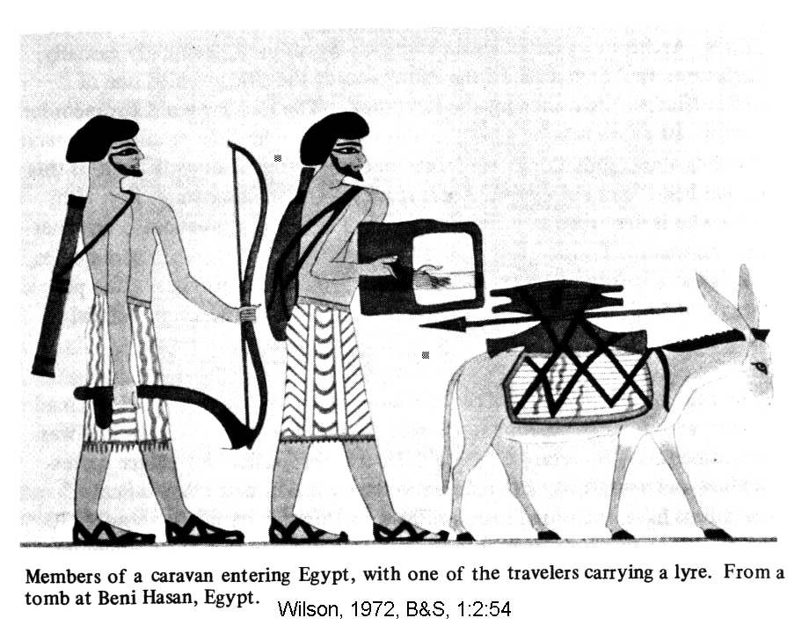

Psalm 29: Canaanite or Hebrew?

Where the Psalms original Israelite traditions, or were they borrowed from the Canaanites? This question can be explored by an analysis of Psalm 29. It is a lightly revised hymn to Ba'al, the storm god. The theophany of the storm god was revised by rhapsodist prophets (Isaiah, Jeremiah) to be the Israelite God (El) who reveals by the word.

1Ascribe to the LORD, O mighty ones,
ascribe to the LORD glory and strength.
2Ascribe to the LORD the glory due his name;
worship the LORD in the splendor of his holiness.

3The voice of the LORD is over the waters;
the God of glory thunders,
the LORD thunders over the mighty waters.
4The voice of the LORD is powerful;
the voice of the LORD is majestic.
5The voice of the LORD breaks the cedars;
the LORD breaks in pieces the cedars of Lebanon.
6He makes Lebanon skip like a calf,
Sirion like a young wild ox.
7The voice of the LORD strikes
with flashes of lightning.
8The voice of the LORD shakes the desert;
the LORD shakes the Desert of Kadesh.
9The voice of the LORD twists the oaks
and strips the forests bare.
And in his temple all cry, "Glory!"

10The LORD sits enthroned over the flood;
the LORD is enthroned as King forever.
11The LORD gives strength to his people;
the LORD blesses his people with peace

In 1 Kings 19:1-3,8-12, we read:

11The LORD said, "Go out and stand on the mountain in the presence of the LORD, for the LORD is about to pass by."
Then a great and powerful wind tore the mountains apart and shattered the rocks before the LORD, but the LORD was not in the wind. After the wind there was an earthquake, but the LORD was not in the earthquake. 12After the earthquake came a fire, but the LORD was not in the fire. And after the fire came a gentle whisper.

WIND, EARTHQUAKE AND FIRE were all natural phenomena attributed to Ba'al the storm god. This litany was recited in ceremonies celebrating the New Year, as seen in the Enuma Elish epic and Poem to Baal. In these stories, the weather god (Baal) defeats a rebellious dragon or monster. The New Year ceremonies were a celebration of this victory.

PHOTO LINK: NINTURA 007 Shell inlay 2800-2600 BC Ninurta slaying 7-headed monster
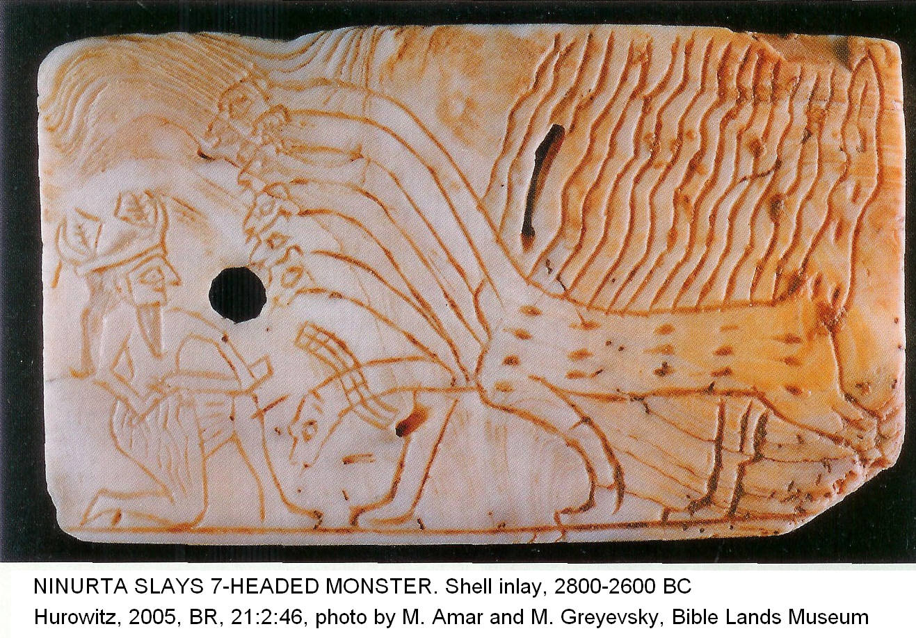

PHOTO LINK: SEA SERPENT 001 Painting

Wheeler (1992) questions this comparison. He says it ist based on preconceived theory of religious parallelism. The ideological thrust between Hebrew and Canaanite versions of the psalm is different. The musical syntax reflects work of one author, not many. The symmetry of the psalm suggests an original work, unchanged since it's composition. There is obvious parallels of the pagan theme and God's war with Lucifer (Satan, Rahab in Ps 89:10, Is 51:9, Job 9:13, 26:12) and Leviathan (Ps 74:14, Is 27:1, Rev. 12:9; 20:2; Wheeler, 1992).

PHOTO LINK: DEVIL 001 Painting
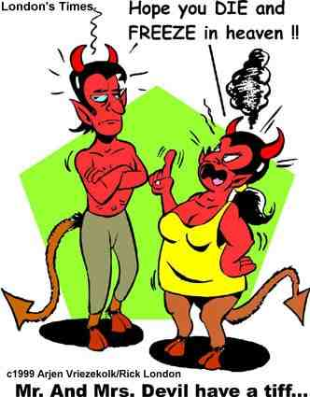
PHOTO LINK: DEVIL 002 Drawing
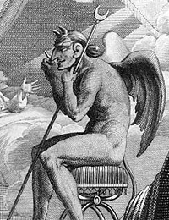

There are no Ugaritic or other Canaanitic texts with which to compare Psalm 29. But Ugaritic-like language of Psalm 29 indicates it was composed before the Babylonian Exile. A Hebrew writer would use Canaanite phases to describe uniquely Hebrew concepts (Wheeler, 1992).

But it is possible that the current symmetry and musical syntax of the psalm are the result of reworking of an older psalm that was borrowed from an earlier Canaanite work (Cross, 1992).

MUSICAL INSTRUMENTS

Harp and Lyre (Hebrew Nevel and Kinnor)

PHOTO LINK: PSALMS 006 Lyre players in Egyptian tomb painting
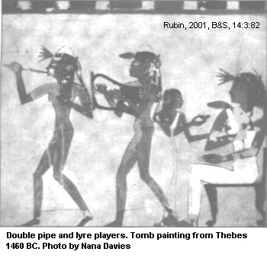

PHOTO LINK: PSALMS 007 Judean captives of Lachish playing lyres from Sennacherib’s palace in Nineveh, 701 BC
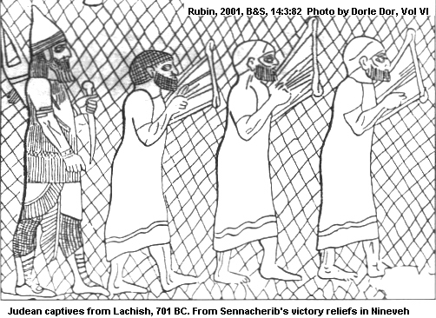

PHOTO LINK: PSALMS 008 Kinnor of Genesis 4:21
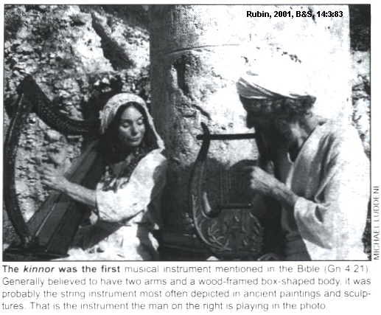

The first mention of a musical instrument in the Bible is in Genesis 4:21: “...Jubal...was the father of all who play the harp and flute.” The “harp” of this verse was probably a kinnor. The kinnor had two arms and a wood-framed box-shaped body (Rubin, 2001).

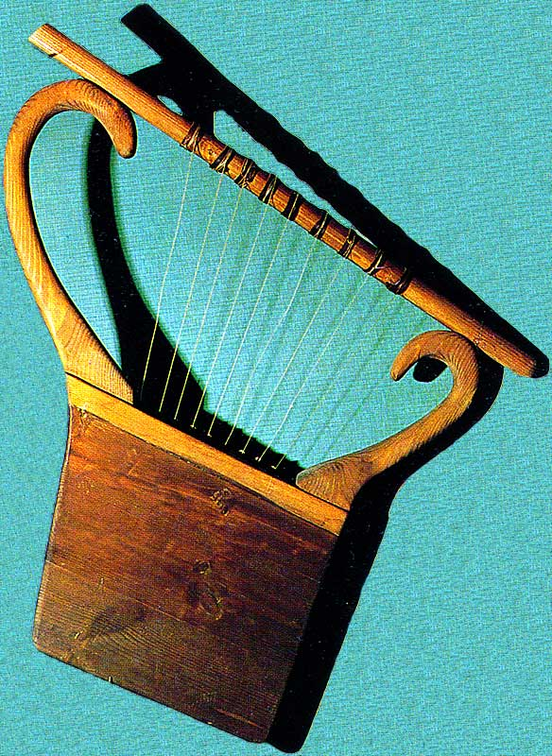
PHOTO LINK: KINNOR 001 Replica of a Kinnor; http://socials-la-wiki.wikispaces.com/file/view/Kinnor.jpg/32723028/Kinnor.jpg; Oct. 23, 2010

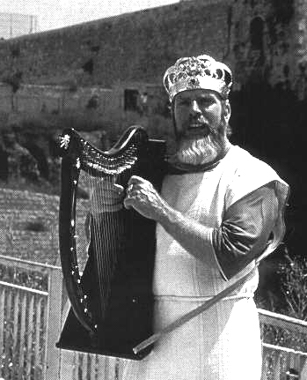
PHOTO LINK: PSALMS 011 King David with harp

PHOTO LINK: PSALMS 013 Harpist and flutist from 3rd century BC tomb painting at Mareshah, south central Israel
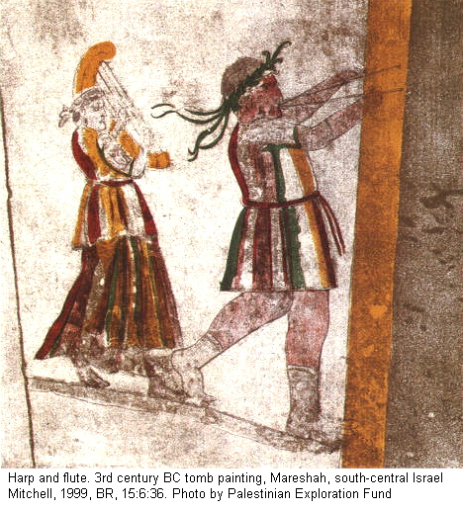

PHOTO LINK: PSALMS 014 8th century relief from Karatepe, Turkey, with drum, lyre and flute
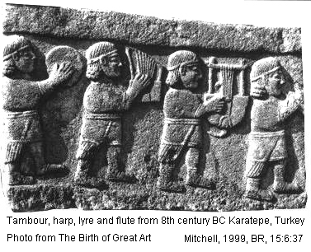

Pipe (Hebrew Halil)

A reed flute (Greek syrinx) was used in rejoicing and mourning ceremonies. It could be a pan-pipe instrument with hollow reeds of different lengths tied together. The flute mentioned in Genesis 4:21 was probably the lute (Hebrew Minnim) which also appears in Psalm 81:3; 150:3 (Rubin, 2001).

PHOTO LINK: PSALMS 010-C Flute
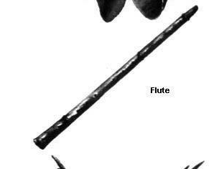

Horns

The horns described in the Hebrew Bible might be a double-pipe wind instrument with one melody pipe and one drone pipe. This type of aerophone (wind instrument) could include pan-pipes or whistles of skin bagpipes (Rubin, 2001).

Castanets of Pottery Rattles

Pottery rattles are the instrument mentioned in 2 Samuel 6:5 and 1 Chron. 13:8. Most rattles are in the form of a spool, with a loop for suspension and are molded in the shape of an animal or fruit. Pebbles or pottery sherds were put inside the rattle to make the noise (Rubin, 2002).

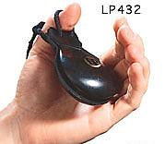
PHOTO LINK: CASTENET 001 simple castanet

PHOTO LINK: CASTENET 002 Finger cymbals or zills.
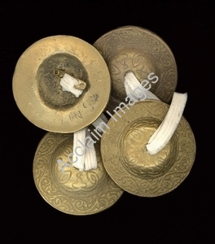

Sistrum and Cymbals

The sliding rattle is known from Roman coins. The cymbals of the Hebrew bible were ‘Mezilayim, Zilzalim, and Mizillot. These were bronze plates with a hollow boss and a metal thumb-loop or had long, thin metal arms about 12 cm in length. Cymbals were played by Levites in the Temple (Rubin, 2002).

PHOTO LINK: PSALMS 010-B Cymbals
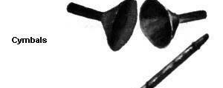

PHOTO LINK: CYMBALS 001 Modern cymbals
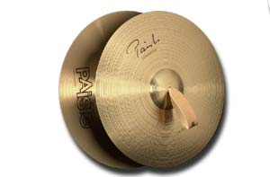

Trumpets

Trumpets of hammered silver were used as calls to worship in Numbers 10:2, 8 and 10. Temple trumpets were made of silver, were long and conical with a broadened bell (Joshua 6:8). They are shown on the Arch of Triumph in Rome depicting the destruction of Jerusalem in AD 70. Trumpets were also used to sound battle cry. Military trumpets were short and broad with a prominent mouthpiece. They are depicted on Bar Kokhah coins minted during the revolt against Rome. Conch shells were also used as trumpets in military settings (Rubin, 2002).

Photos and audio of the Trumpet of Tutankhamen can be found at http://213.132.220.88/ccer/article21.html (Aug. 6, 2006).

PHOTO LINK: TUTANKHAMUN 004 Trumpet of Tutankhamen
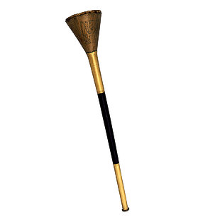

Shofar

The shofar was made from a ram’s horn. The shofar is mentioned during the siege of Jerusalem and in the conquest of Jericho. It was a military signaling device up to the Second Temple period. At that time it was adopted into the Yahwist liturgy. The Mishnah (Rosh Hashana 16) relates that a shofar made from a straight ram’s horn an fitted with a gold mouthpiece was sounded on the Jewish New Year. A curved shofar with a silver mouthpiece was sounded on the Day of Atonement (Rubin, 2001).

PHOTO LINK: PSALMS 009 Shofar horn
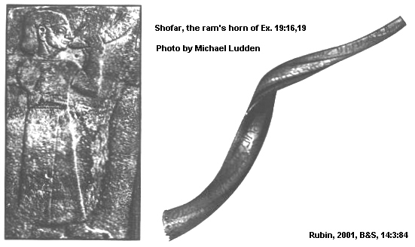

PHOTO LINK: PSALMS 012 Shofar and mosaic floor from 5th century BC Synagogue at Beth-Shean
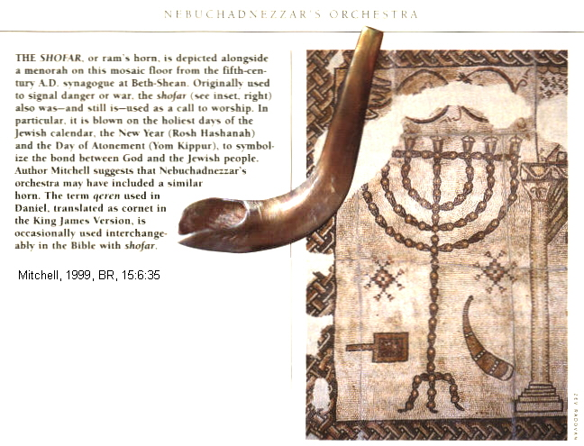

Bells (Hebrew Pa’amon)

Robes for the High Priest contained gold bells (Exodus 28:33).

31 "Make the robe of the ephod entirely of blue cloth, 32 with an opening for the head in its center. There shall be a woven edge like a collar around this opening, so that it will not tear. 33 Make pomegranates of blue, purple and scarlet yarn around the hem of the robe, with gold bells between them. 34 The gold bells and the pomegranates are to alternate around the hem of the robe. 35 Aaron must wear it when he ministers. The sound of the bells will be heard when he enters the Holy Place before the LORD and when he comes out, so that he will not die.

PHOTO LINK: BELLS 001 Bells sewn into hem of garment
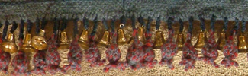

PHOTO LINK: EPHOD 001 Aaron wearing ephod with robe hemmed with gold bells and pomegranates.
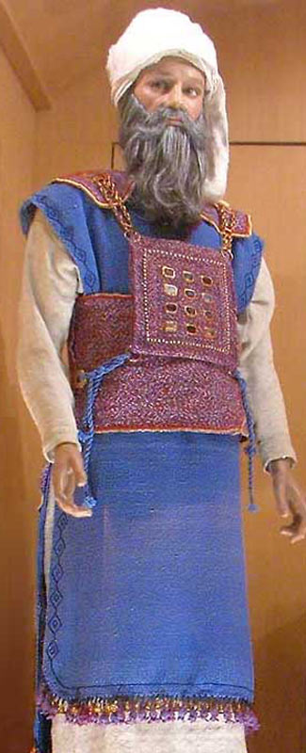

Tambourine or timbrel

The tambourine or frame skin-taut drum (timbrel) was used in association with song and dance: “Let them praise his name with dancing and make music to him with tambourine and harp” (Psalm 149:3; Rubin, 2001).

PHOTO LINK: TAMBOURINE 001 Figurine with tambourine Cyprus Iron Age
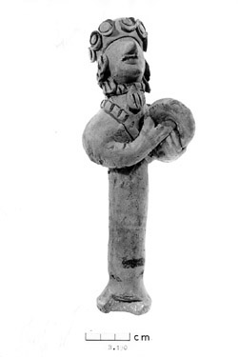

PHOTO LINK: TIMBREL 001 Woman with timbrel, figurine, 6th century BC, Cyprus

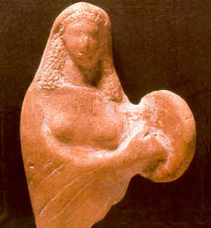

PHOTO LINK: TAMBOURINE 003 Modern tambourine, Israel
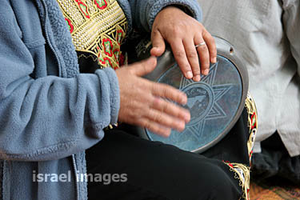

Drum (Hebrew tov) and Membraphone (Hebrew tof)
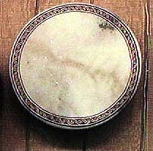
Miriam dances with tambourines in Exodus 15:20. In this passage, the Hebrew word is tov, meaning drum. The membraphone (also called timbrels) was a instrument that produced sound by means of vibration of a tightly framed skin membrane. They could have single-frame drums or double-membrane drums with skins tightly framed on both ends (Rubin, 2001).

Friction timbrels produce sound by being rubbed with the hand or set into vibration by a friction cord or stick (Rubin, 2001).

PHOTO LINK: DRUM 001 Modern single-frame drum (ABOVE)

Zither
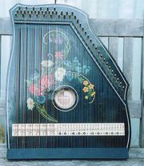
Modern zither instruments have 30 to 40 strings over a shallow horizontal soundboard. They are played by plectrum and fingers. Ancient zithers were made from a variety of materials including wood xylopones, musical glasses, stones chipped to give a graded sound scale, reeds, nut shells, and upturned metal bowls (Rubin, 2001).

PHOTO LINK: ZITHUR 001 Modern zithur (RIGHT)

Triangle

The triangle was a percussion instrument. Like today’s triangle, it was made of steel or iron and was open at one corner. It was struck by a metal rod (Rubin, 2001).

PHOTO LINK: TRIANGLE 001 Modern triangle musical instrument
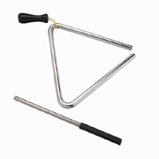

Dulcimer

The modern dulcimer is a wire-stringed instrument of trapezoidal shape played with light hammers held in the hands. Ancient dulcimers used small metal or wood hammers (Rubin 2001). An Assyrian relief interpreted as a dulcimer in 1850 was re-interpreted as a horizontal harp in 1979 (Mitchell, 1999:38).

PHOTO LINK: DULCIMER 001 Paleozoic cave painting
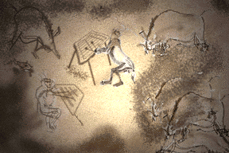
PHOTO LINK: DULCIMER 002 Assyrian dulcimer
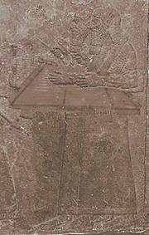

PHOTO LINK: PSALMS 015 Dulcimer of 1850 shown to be horizontal harp in 1979
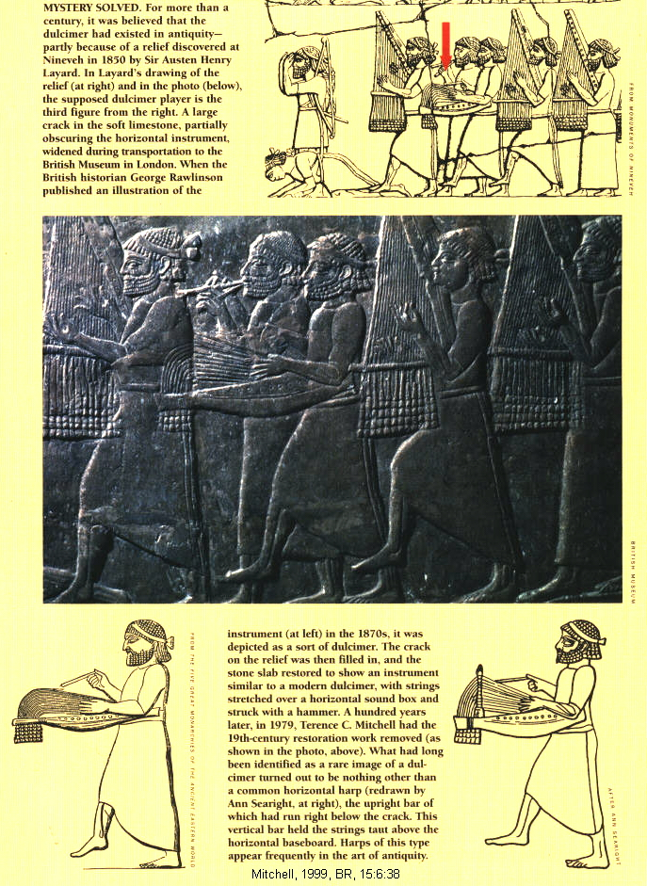

MUSIC OF THE TEMPLE

All scriptural and epic poetry was intended to be sung or chanted. Singing helped with memorization of the stories. Writing, if present, was only read and written by a few religious or political leaders. The earliest biblical song is found in Ex 15:1-18, the “Song of Moses” which follows the crossing of the Red (Reed) Sea. There was professional character to Israelite liturgical music. The music of worship was serious business that required lifetime study and dedication. A musical interpretation of Masoritic text accents has lead to reconstruction of temple music for Psalms and prose texts. The purpose of accent notations were threefold (Wheeler, 1989):

a) They define the melody to which Scripture was to be sung
b) They mark the stressed syllables of the Hebrew words
c) They indicate the punctuation and syntax

PHOTO LINK PSALM 002 Prosodic System Example
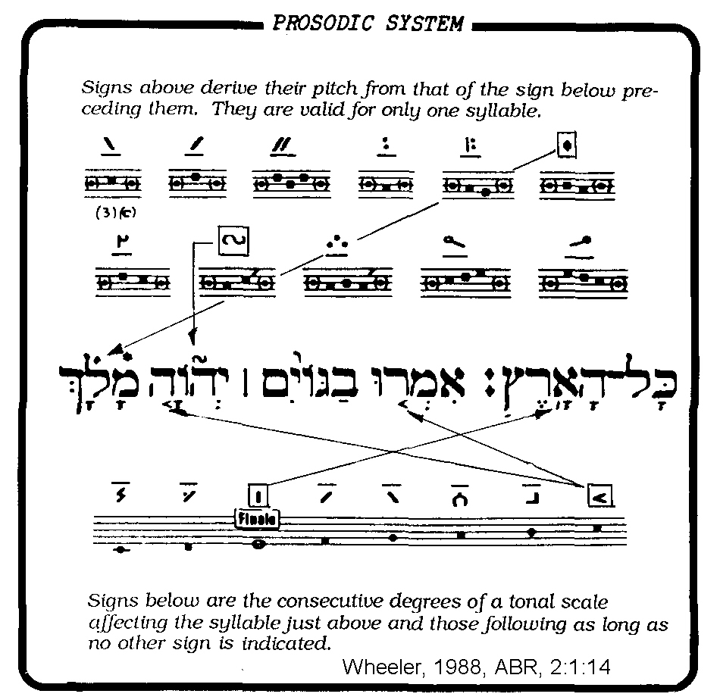

The Masorites knew they had a text that included a musical notation, but they were not able to explain it musically. Since the Renaissance, everyone thought that the Masorites were the inventors of this notation. Now it appears they inherited and preserved an older writing tradition having musical meaning (Wheeler, 1989).

The signs below the textural line represented 8 degrees of a musical scale based on steps and half-steps. The signs above the text represented special ornamentations to be sung on one syllable. This interpretation of the Masoritic script agrees with a musical sign-language depicted in Egyptian hieroglyphs, a gesture system called cheironomy (Wheeler, 1989).

PHOTO LINK: PSALMS 003 Hand Signs
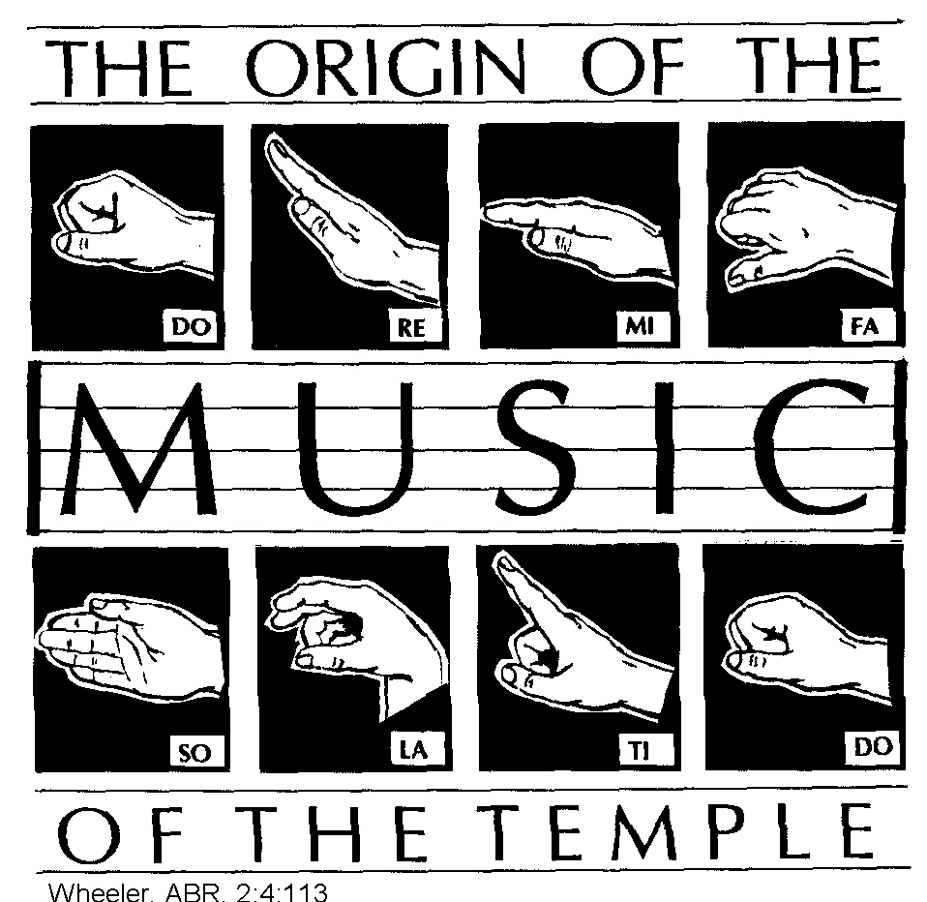

This hand signal system is reflected in the phrase "hands of David" (“supervision” NIV) found in the Old Testament (see 1 Chon 25:1-6). This correspondence suggests that every Biblical authors (or editors) from Moses to Malachi were poet-musicians. Personal musical styles are now evident for different biblical author-musicians. This suggests a unity of authorship for groups of Psalms and an over-all editorial philosophy for the Psalms as a whole. This correlation is difficult to explain in terms of late invention by Maccabaeus (Wheeler, 1989). Many of the Psalm titles are musical introductions.

TRANSLATION OF ME'OD IN PSALMS 46 AND 78 AND THE EBLA TABLETS

The Ebla Tablets have a possible connection to Psalms 46 and 78. There is a title of deity and two related phrases translated “The Grand” (Dahood, 1979). These and their corresponding Hebrew and English translations are shown in the table below:

Ebla | Hebrew | English Translation
MA-DA | ME'OD | The Grand (formerly translated "much")
da-si-ma-ad | da-si-ma-ad | The he-goat of the Grand
en-na-ma-ad | en-na-ma-ad | Have mercy O Grand (see Ps 46:2 and 78:49)

If this correspondence is correct, it suggests that these Psalms carry traditions that go back to the time of the Patriarchs.

TEARS AND THE BELLY: PSALM 31

Psalm 31:10 reads "...for distress in mine; my eye is wasted away with sorrow, my throat and my belly”. The meaning of this verse is illuminated by comparison to Ugaritic texts. The Ugaritic material indicates that Canaanite poets and physicians believed that tears originated in the liver or belly, passed though the throat, and issued from the eyes. A companion motif can be seen in Lamentations 2:11 where we read that "his liver has been poured out upon the ground" (Dahood, 1979).

REPETITIONS IN PSALMS SEEN TO BE ANCIENT POETIC PATTERN

Psalms 92:10 reads, "Now see how your foes, Yahweh, see now how your foes have perished, how all the evildoers have been scattered". This verse can be compared with the Ugaritic refrain "Now your foes, Baal, now your foes you will smite, now you will suppress your adversaries". So this is NOT a case of textural error during transmission, the duplication reflects an ancient literary custom. (Dahood, 1979, p.64)

DATE AND AUTHORSHIP OF PSALMS

Many of the Psalms are attributed to David. Liberal minimalists say David did not write any of them. They contend that the Psalms were composed by the Maccabaeus about 800 years later (Wilson, 1972).

Ras Shamra Tablets

Some expressions in some Psalms that are similar to expressions found in the Ras Shamra tablets which were out of date by Maccabeus times but common in David's time (Wilson, 1972).

PHOTO LIK: RAS SHAMRA TABLETS 001 Photo and drawing of tablet, Ugarit Photo and drawing of Ras Shamra tablet ; http://oi.uchicago.edu/OI/IS/PARDEE/NN_WIN02/NN_Win02_fig4.html ; July 29, 2006
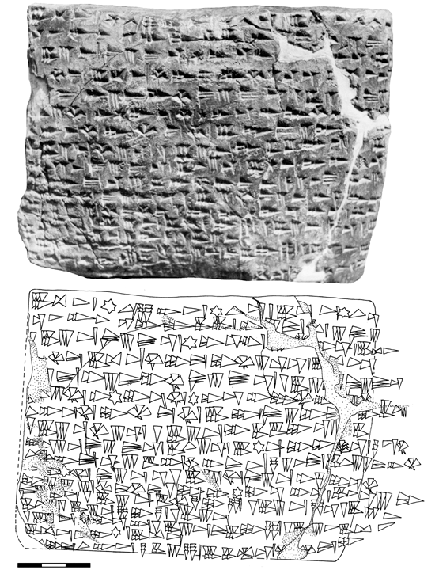

The title of "Jehoshaphat the Recorder" of 2 Sam 8:16 is parallel to Egyptian usage of the Davidic period. This official was a herald or liaison officer/public relations specialist (Wilson, 1972).
.
The title of "Scribe" in 2 Sam 8:17 is parallel to the Egyptian title "Royal Scribe”. The Ras Shamra tablets indicate that the Canaanites had a similar office. This similarity suggests that the Psalms date from the time of David. Music guilds set up by David are parallel to passages in some Ras Shamra tablets that indicate that by 1400 BC singers were a distinct group of temple servants. The Hebrew word sharim means "singer". It is a Canaanite word.

Psalms 88 and 89 refer to two persons known as Ezrahites. Ezrah means native born. So this indicates that David used some Canaanite proselytes to help run the Temple (Wilson, 1972).

Stringed instruments (lyres) were known in David's day. Tomb paintings at Beni Hasan in Egypt show the presence of this type of instrument. The paintings are from the same period as the United Monarchy. Harps are also found in Ur Royal Death Pits from the same time period (Wilson, 1972).

Dating of Psalms from Abecedaries

Michelle First (2012) suggested that some psalms could be dated by the acrostic patterns in them. An acrostic is a series of lines in a poem that begin with words starting with successive letters of the alphabet.

English and Latin: A, B, C, …
Greek: alpha, beta, gamma…
Hebrew: aleph, beth, gimel ….

The shape of letters, and the order of letters in the Hebrew alphabet changed over time. The changes can be observed in abecedaies recorded in stone inscriptions from different places and dates.

In the earliest Hebrew scripts, the order of letters ayin (English “o”) and pe (English ‘p”) were reversed compared to later Hebrew scripts. And the old inscription ayin was written with a dot in the center, which was later omitted (First, 2012:54).

This reversal of letters is observed in the Izbet Zartah abecedary (12 century C) and in the Tel Zayit abecedary (10th century BC) (First, 2012:54)

PHOTO LINK: IZBET SARTAH OSTRACON 008 Drawing and photograph of the Izbet Sartah abecedary ostracon.

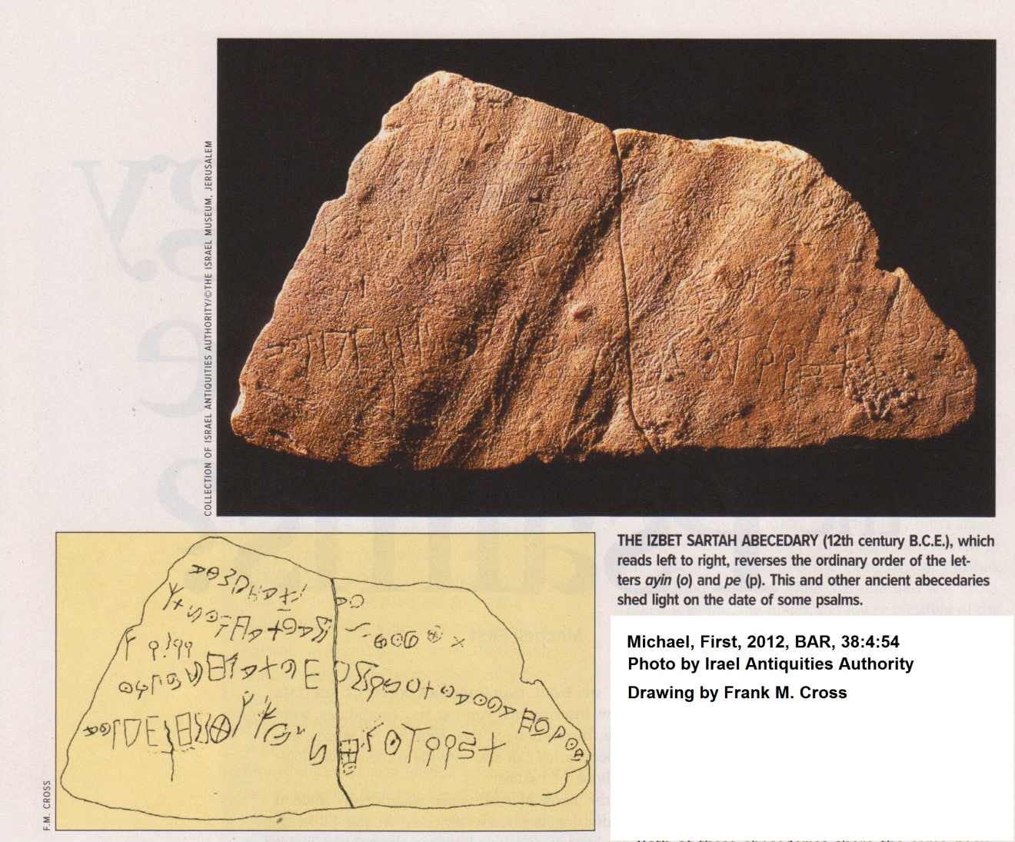

PHOTO LINK: TEL ZAYIT STONE 004 Photo and drawing of inscription
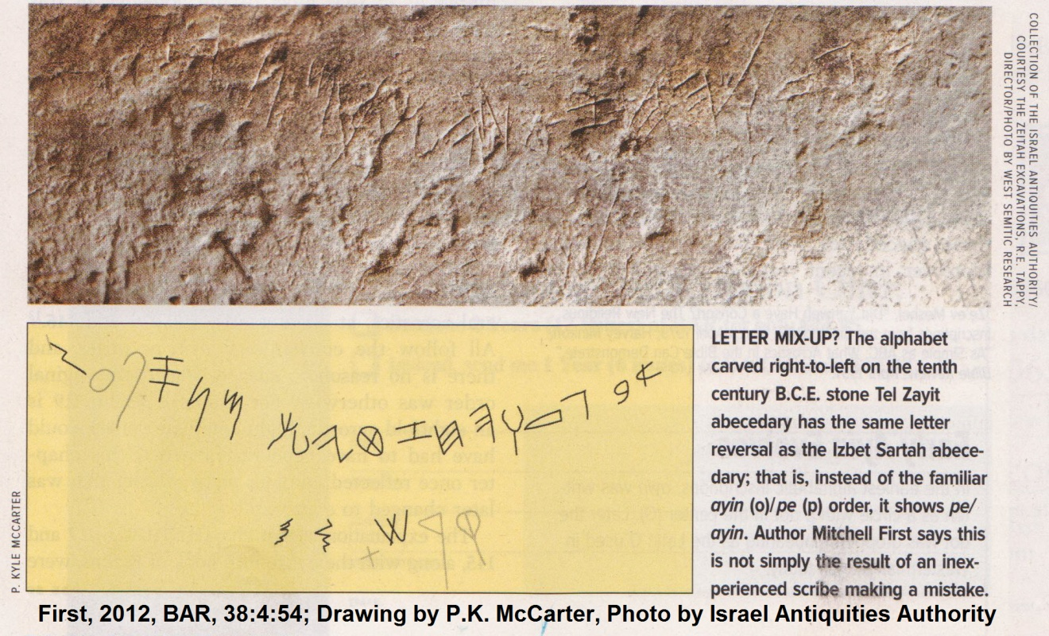

Alphabetic acrostics appear in Psalms 9-10, 25, 34 and 37 in the “First Book” comprising Psalms 1-41 (First, 2012:54).

Editing has re-arranged some verses, to maintain later ayin (o)/ pe (p) order of the acrostics, but in the process make some texts illogical, as seen in Psalms 34:15-18. First (2012) makes the following observations:

In verse 34:16 (English , verse 15) we are told:

“The eyes (ayin) of the Lord are on the righteous,/ and his ears attentive to their cry.”

In verse 34:16 (English, verse 15) wer are told:

“The face (pe) of the Lord is set against evildoers, / to erase their names from the earth."

Yet immediately following this, at 34:18 (English, verse 17), we are told without explanation:

"They cry out (tzade) and the Lord hears, and saves them from all their troubles."

Why should God listen to and save the evildoers, when we have just been told that he wants to erase their remembrance from the earth? But if we make the assumption that pe preceded ayin here, the theological problem disappears and the sequence of verses makes perfect sense: [The correct order of verses should be]

34:17: "The face (pe) of the Lord is set against evildoers, / to erase their names from the earth."
34:16: "The eyes (ayin) of the Lord are on the righteous, / and his ears attentive to their cry."
34:18: "They cry out (tzade) and the Lord hears, and saves them from all their troubles."

The ones whom God listens to and saves are not the evildoers but the righteous ones! The likely original pe/ayin order in chapter 34 makes us suspect that the three other acrostics in the first book (= the same collection) might also have been composed with the pe/ayin order. Although this cannot yet be proven, there are strong arguments to support this. For example, in the acrostic that spans chapters 9 and 10, it is fairly clear that our text is corrupt, since the acrostic only includes 15 of the 22 letters. But many scholars believe that the words r 'r/pe (verse 10:7, second word) and i''1'/ayin (verse 10:8, third to last word) were once the first words of pe and ayin verses in the pe/ayin order in the original text (First, 2012, 54-55)

It is very likely that, during the earliest Israelite times, the Hebrew alphabetic order was exclusively pe/anyin, and that this was the order through the end of the First Temple period (c. 1000-586 BC)(First, 2012:55)

There are several other artifacts that indicate that the pe/ayin order is the original, and that it later changed to ayin/pe.

PHOTO LINK: ALPHABET 007 Photo and drawing of abecedaries on Kuntillet 'Ajrud pithos early 8th century BC showing pe/ayin order of the alphabet.

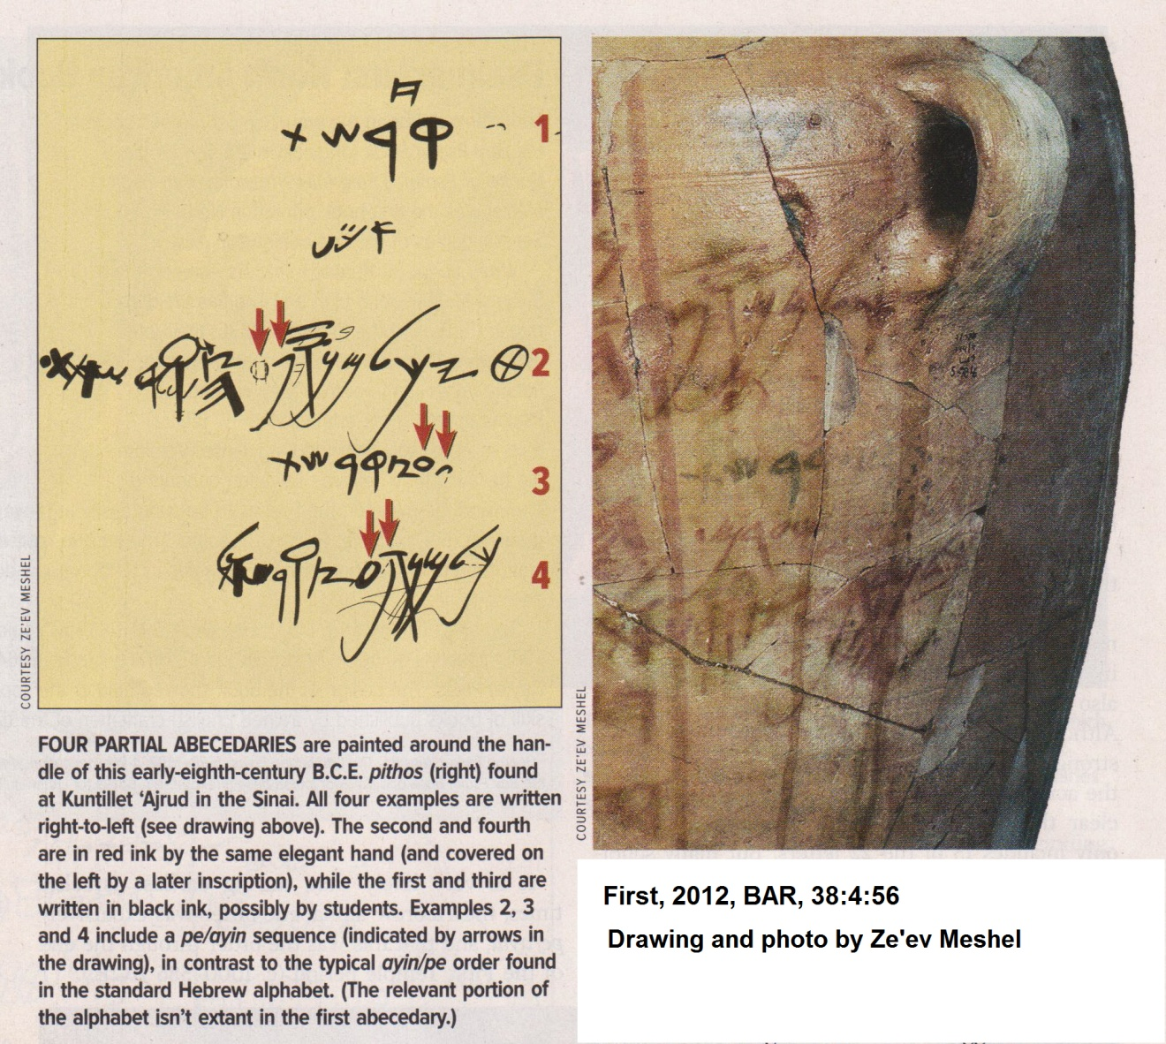

The 5th book of Psalms (Psalms 107 to 150) include several acrostics in Psalm 111, 112, 119 and 145. All of these use the conventional, late, ayin/pe order. This indicates that Book 5 is composed after the Babylonian exile, when the ayin/pe order was introduced to Israel (First, 2012:66).

PROVERB

Traditionally, King Solomon is considered to be the author of Proverbs. He probably did collect or write many of them, as indicated by 1 Kings 4:32 where 3,000 proverbs are attributed to him. Solomon’s proverbs would have been written in the 10th century BC. Other authors are indicated by Proverbs 22:17-21 which introduces a section composed by a circle of wise men, not by Solomon himself. Chapter 30 is attributed to Agur son of Jakeh and 31:1-9 to King Lemuel, neither of whom is mentioned elsewhere. Lemuel's sayings contain several Aramaic spellings that point to a non-Israelite background (Compton’s Interactive Encyclopedia, 1998).

The headings in 1:1. 10:1 and 25:1 include Solomon’s name. But 25:1 states that the proverbs were copied by the men of Hezekiah. That group of editors compiled and edited the Proverbs from 715 to 686 BC. The sayings of Agur (ch. 30) and Lemuel (31:1-9) and the other "sayings of the wise" (22:17-24:22; 24:23-34) may have been added at this time, but could be earlier (Compton’s Interactive Encyclopedia, 1998).

The book contains a short prologue (1:1-7) and a longer epilogue (31:10-31), which may have been added to the other materials. It is possible that the discourses in the large opening section (1:8-9:18) were the work of a compiler or editor, but the similarities of this section with other chapters (compare 6:1 with 11:15; 17:18; 20:16; 27:13; compare 6:19 with 14:5,25; 19:5) fit a Solomonic origin equally well. The emphasis on the "fear of the LORD " (1:7) throughout the book ties the various segments together. (Compton’s Interactive Encyclopedia, 1998).

Sumerian Proverbs

We know of Sumerian Proverbs that are 5000 yrs old which have similarities to Biblical proverbs (Wood M.L., 1979):

A restless woman in the house
Adds ache to pain

Who possesses much silver may be happy
Who possesses much barley may be happy
But who has nothing at all can sleep

Friendship lasts a day
Kinship endures forever

Ugaritic Proverbs

Some proverbs give warnings against involvement with prostitutes. Proverbs 2:18 reads "Her house goes down to Death, and her steps to the Shades. At Ugarit, a Ras Shamra family burial vault was directly underneath house with steps going down to it (Dahood, 1979, p.63).

Proverbs 25:22 reads "If you heap burning coals on his head, Yahweh will reward you" . The Hebrew word is 'al, and is usually translated "on". But from Ugarit tablets we know that 'al can also mean "from". An uncontested use of ‘al as “from” is found in Is 30:14 which reads "Among its fragments not a sherd is found with which to snatch coal from the hearth". So it makes more sense to translate this verse "If you snatch (same verb as in Is 30:14) burning coals upon his head, Yahweh will reward you" (Dahwood, 1979)

Phonician Proverbs

Proverbs 27:24 reads "Wealth does not endure forever or the crown for generation to generation". The imagery describes the shared power condition of Phoenician city-state (elders/merchant-king) political/economic system and is also reflected at Ebla with it's seven-year election of its king (Dahood, 1979).

Egyptian Proverbs

Instructions of Amenemope

There are a number of similarities between Proverbs 22:17-23:5 and the Egyptian Instructions of Amenemope These writings date to the 7th or 6th century BC. The sayings are written in hieratic script on papyrus. The Instructions are intended to prepare a young man for prosperous, upright lives (Van der Toorne, 2000:28).

PROVERBS | INSTRUCTIONS OF AMENEMOPE
Incline your ear and hear my words  and apply your mind to my teaching  (Proverbs 22:17) | Give thy ears, hear what is said  Give thy heart to understand them  To put them in thy heart is worth while (Chapter 1)
Do not remove the ancient landmark  that your ancestors set up  Do not remove an ancient landmark  or encroach on the fields of orphans  (Proverbs 23:4-5) | Do not carry off the landmark at the boundaries of the arable land.  Nor disturb the position of the measuring-cord:  Be not greedy after a cubit of land  Nor encroach upon the boundaries of a widow (Chapter 6).
Do not wear yourself out to get rich  be wise enough to desist  When your eyes light upon it, it is gone:  for suddenly it takes wings to itself,  flying like an eagle toward heaven  (Proverbs 23:4-3) | Do not strain to seek and excess  Ehen thy needs are safe for thee.  If riches are brought to thee by robbery,  They will not spend the night with the;  At daybreak they are not in thy house;  Their places may b seen, but they are not  The ground has opened its mouth...  That it might swallow them up,  And might sink them into the underworld  (OR) they have made themselves a greed breach of their (own) size  And are sunken down into the underworld.  (Or) they have made themselves wings like geese  And are flown away to the heavens (Chapter 7)
Make no friends with those given to anger  and do not associate with hotheads (Proverbs 22:24) | Do not associate to thyself the heated man  Nor visit him for conversation (Chapter 9)
Do not eat the bread of the stingy:  Do not desire their delicacies;  for like a hair in the throat, so they are ...  You will vomit up the little you have eaten,  and you will waste your pleasant words  (Proverbs 23:6-8) | Be not greedy for the property of a poor man,  Nor hunger for his bread  As for the property of a poor man, it (is) a blocking to the throat...  The mouthful of bread (too) great thou sallowest and vomitest up,  And art emptied of thy good (Chapter 11)
When you sit down to eat with a ruler,  observe carefully what is before you,  and put a knife to your throat  if you have a big appetitive,  Do not desire the ruler’s delicacies  for they are deceptive food. (Proverbs 23:1-3) | Do not eat bread before a noble,  Nor lay on the mouth at first.  If thou art satisfied with false chewings,  They are a pastime for thy spittle.  Look at the cup which is before thee.  And let it serve thy needs. (Chapter 23).
Have I not written for you thirty sayings  of admonition and knowledge,  to show you what is right and true,  so that you may give a true answer to those who sent you? (Proverbs 22:20-21) | See thou these thirty chapters;  They entertain; they instruct  They are the foremost of all books;  They make the ignorant to know.  If they are read out before the ignorant,  Then he will be cleansed by them (Chapter 30).

Instructions of Ankhsheshonq

There are additional similarities between other Egyptian works and sayings in Ecclesiastes. These are the Instructions of Ankhsheshonq recorded on the Papyrus Insinger. These are from the Ptolemaic period (3rd century BC). Like Ecclesiastes, there is a determinism in the Egyptian texts: human happiness is entirely at the whim of the gods:

ECCLESIASTIES | INSTRUCTIONS OF ANKHSHESHONQ
18Then I realized that it is good and proper for a man to eat and drink, and to find satisfaction in his toilsome labor under the sun during the few days of life God has given him--for this is his lot. 19Moreover, when God gives any man wealth and possessions, and enables him to enjoy them, to accept his lot and be happy in his work--this is a gift of God. 20He seldom reflects on the days of his life, because God keeps him occupied with gladness of heart.  (Ecclesiastes 5:18-20) | It is the god who gives wealth and poverty according to that which he has decreed, the fate and fortune that come, it is the god who determines them (Litchtheim, 1973:196-197)
1So I reflected on all this and concluded that the righteous and the wise and what they do are in God's hands, but no man knows whether love or hate awaits him. 2All share a common destiny--the righteous and the wicked, the good and the bad, A the clean and the unclean, those who offer sacrifices and those who do not.  As it is with the good man,  so with the sinner;  as it is with those who take oaths,  so with those who are afraid to take them.  3This is the evil in everything that happens under the sun: The same destiny overtakes all. The hearts of men, moreover, are full of evil and there is madness in their hearts while they live, and afterward they join the dead. 4Anyone who is among the living has hope even a live dog is better off than a dead lion!  (Ecclesiastes 9:1-4) | All good fortune is from the hand of the god (Litchtheim, 1973:175; Papyrus Insinger )  He lets the destiny of those on earth be hidden from them, so as to be unknown (Litchtheim, 1973:209-211; Ankhsheshonq 32.18)
...cast your bread upon the waters, for you will find it after many days. (Ecclesiastes 11:1) | Do a good deed and throw it in the water, when it dries, you will find it (Ankhsheshonq 19:10)
He who quarries stones is hurt by them (Ecclesiastes 10:9) | He who shakes the stone will have it fall on his foot (Litchtheim, 1973:176; Ankhsheshonq 22.5)

The Biblical Proverbs are similar to those of contemporary middle-eastern civilizations and suggests that the original materials in some of them (Book 1) date to the time of King Solomon, or earlier.

