CHAPTER 12: EBLA

Contents
EBLA 1109
THE EBLA TABLETS 1113
Personal and Place Names 1115
Ebla Creation Story 1116
ARCHAEOLOGY OF EBLA 1116
EBLAITE SOCIETY 1122
ECONOMY OF EBLA 1122
LANGUAGE OF EBLA COMPARED TO HEBREW 1123
RELIGION AT EBLA 1123
Table of Divine Names 1126
Eblaite Religion and the God of Israel (Ya, Yahweh) 1130
Eblaite Gods in relation to Israelite Theology and Poetry 1131
EBLA AND THE PATRIARCHS 1132
Nimrod 1132
Adam and Eve 1132
Keturah 1132

Archaeological studies at Ebla provide an interesting case study of how such discoveries can be sensationalized and have a wide spectrum of interpretation concerning their relevance to understanding the Patriarchal narratives (Millard 1992; Livingston, 1992; Dahood, 1979, 1980; Pettinato, 1979; and Kitchen, 1978). Today the Ebla data has proved to be substantiating but not revolutionizing in our understanding of Biblical archaeology.

EBLA

Ebla was known from more than a dozen Sumerian and Akkadian texts but its geographic location was a mystery until discoveries by Paolo Matthiae beginning in 1964. The site is Tell Mardikh and was excavated between 1968 and 1975 (Millard 1992; Livingston, 1992; Dahood, 1979, 1980; Pettinato, 1979; and Kitchen, 1978).

PHOTO LINK: EBLA 001 Location map
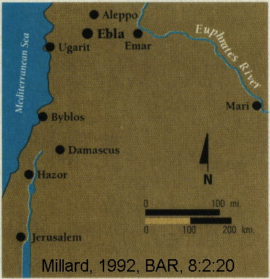

PHOTO LINK: EBLA 015 Location map
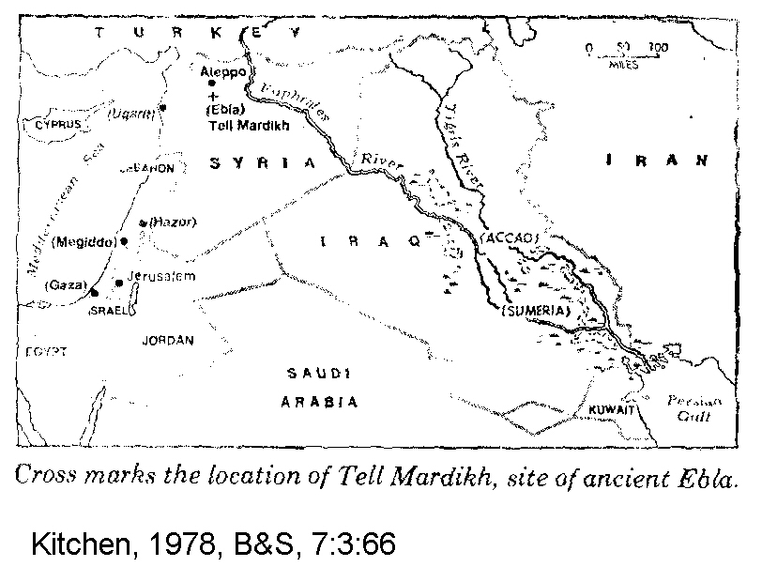
PHOTO LINK: EBLA 014 Aerial photograph
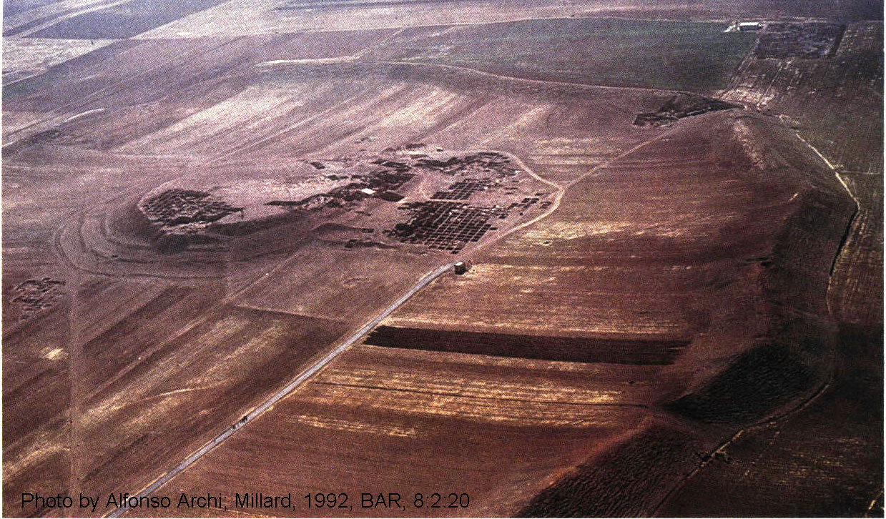

The tell is 100 feet above plain and 140 acres in size. The initial discovery was made by a plowing farmer who unearthed a carved double basin. Tell Mardikh is in northwest Syria, 34 miles south of Aleppo. At Ebla were found 16,500 cuneiform tablet fragments (Millard 1992; Livingston, 1992; Dahood, 1979, 1980; Pettinato, 1979; and Kitchen, 1978).

PHOTO LINK: EBLA 005 Ebla tablets
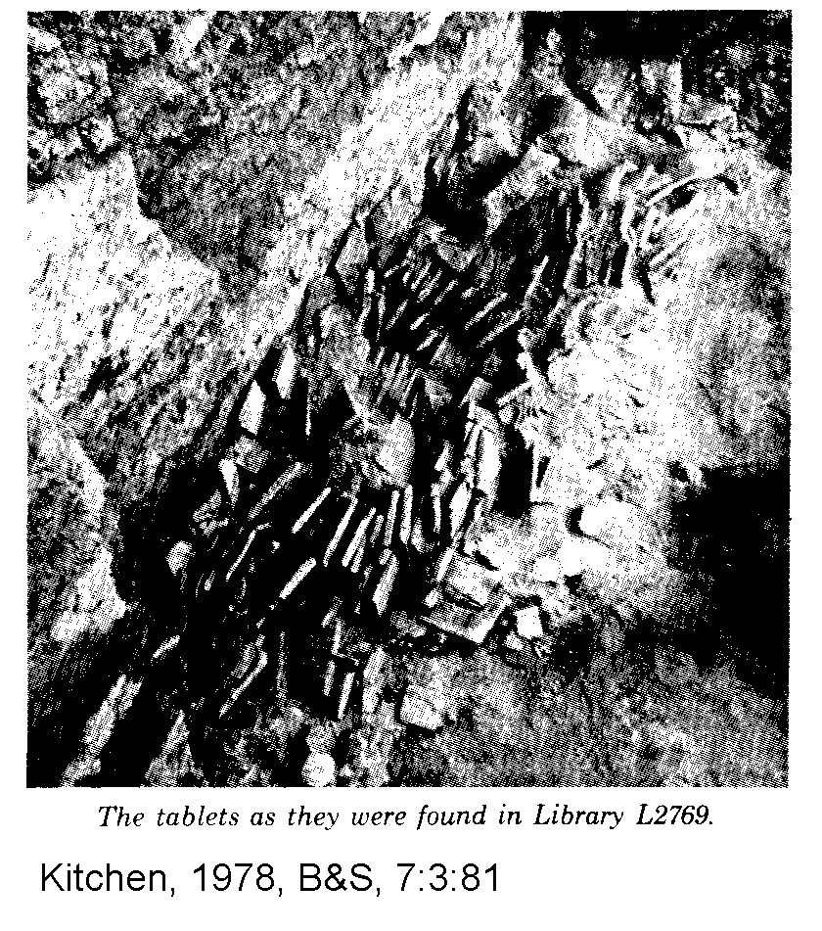

PHOTO LINK: EBLA 006 Ebla tablets
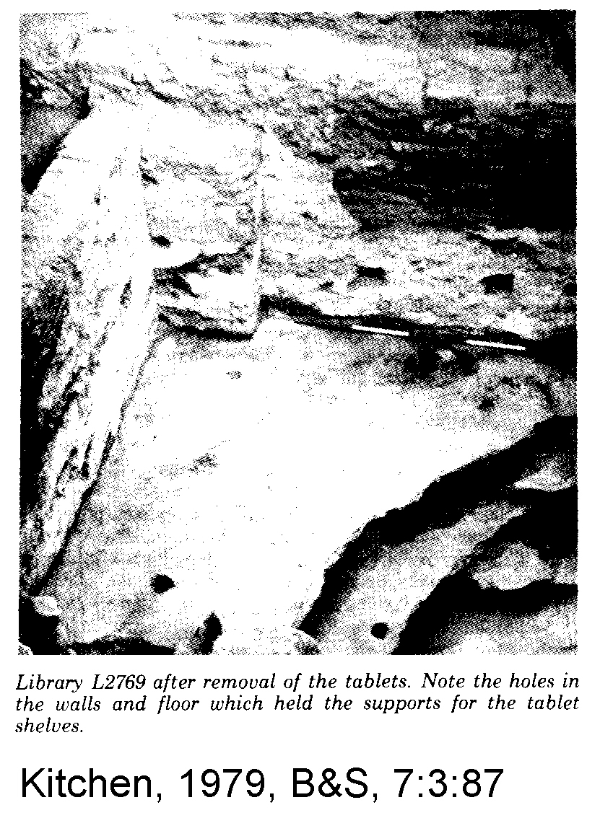

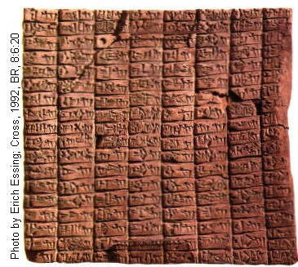
PHOTO LINK: EBLA 021 Ebla tablets (RIGHT)

THE EBLA TABLETS

Only 42 tablets were uncovered in 1974 but over 10,000 tablets in 1975 and over 600 tablets in 1976. There are 7,000 complete tablets, and 50,000 are fragmentary. The tablets are flat slabs of clay about 12 inches square with as many as 3000 lines each. One slab contains about 50 pages of 30 lines each in English writing. Some tablets the size of hamburgers, others as small as one square inch. Among the artifacts found at Ebla, a headless bust with inscription dedicated to the goddess Ishtar by king (or prince?) Ibbit-Lim, son of Igrish-Khepa, or the "family of Ebla" (Millard 1992; Livingston, 1992; Dahood, 1979, 1980; Pettinato, 1979; and Kitchen, 1978).

PHOTO LINK: EBLA 011 Tablets as discovered
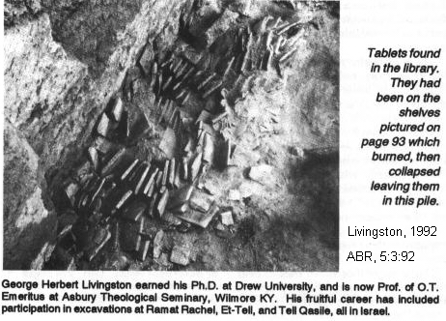

PHOTO LINK: EBLA 016 Torso of king Ibbit-Lim
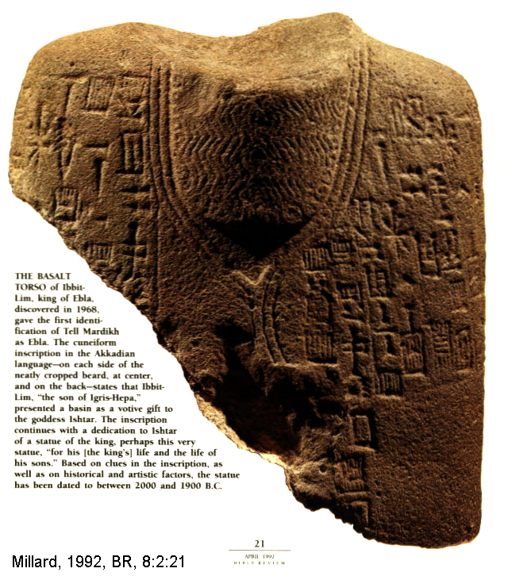

Most (80%) of the Ebla tablets concern mundane administrative records, account files and receipts. There are about 250 bilingual dictionaries (Sumerian word signs and Semitic syllabic signs), encyclopedic lists of animals, birds, precious and non-precious metals, government documents (treaties, letters, laws, reports on military campaigns) and also some mathematical calculations, magical charms and hymns (Millard 1992; Livingston, 1992; Dahood, 1979, 1980; Pettinato, 1979; and Kitchen, 1978).

Personal and Place Names

Sensational claims between 1973 and 1980 about Ebla were made. Close affiliation with the Patriarchal narratives was identified. This early enthusiasm was reassessed beginning in 1977. Part of the early claims of biblical connections to Ebla involved place-names. The word 'e-ma-raKI was interpreted as a reference to Gommorah. The superscript KI means this is a city. A more probably interpretation of this word is Emar. a major town and trading partner on the Euphrates River. Similarly, the word si-da-muKI was interpreted as Sodom. But the only link with that biblical city name is similarity in sound. An alternative interpretation is that this name is of a not-yet-located city in northwest Syria. This geographic placement of si-da-muKI is indicated by associated names of known cities that are located there. Those associated cities are not in Dead Sea. Other (now contested) place names are Aphek, Ashdod, Dor, Jaffa, Gaza, Jerusalem, Samaria, Shechem, Maroth and Hazor (Livingston, 1992). Similar arguments disposed all biblical cities supposedly mentioned in Ebla tablets (Millard, 1992).

Ebla Name | Biblical Place
'e-ma-raKI | Gommorah
si-da-muKI | Sodom

Other evidence cited as support of the biblical significance of Ebla came from an analysis of personal names in the tablets. It was never claimed that these were the same as biblical personages. The presence of names like Israel, Ishmael, Michael and Abram is NOT a surprise. These same names are found in other texts in places hundreds of miles away from Ebla and centuries apart. The word Ebrium or Ebrum was translated as the name of vizier at Ebla. The word was compared to biblical Eber (heb 'br), but more likely this word is based on Akkadian barum = "to see". Ebrium belongs to group of words meaning "he has seen", the subject being a god. So Ebrium has nothing to do with similar sounding biblical names (Millard 1992; Livingston, 1992; Dahood, 1979, 1980; Pettinato, 1979; and Kitchen, 1978).

Other (some contested) personal names at Ebla are Adam, Eve, Tubal, Noah, Abram, Ishmael, Hagar, Keturah, Bilhah, Israel, Micah, Michael, Saul and David (Livingston, 1992).

Some of the inscriptions are in Sumerian and others are in Old North Semitic. Sumerian is largely logographic, each sign represents a word. Semitic cuneiform is largely syllabic with each sign representing syllables. For a discusion, see "Complexities of Cuneiform" in Millard (1992, p.23). Scribes used the old Sumerian pictographs and newer Semitic syllable signs interchangeably for different applications and differently as time passed by (Millard 1992; Livingston, 1992; Dahood, 1979, 1980; Pettinato, 1979; and Kitchen, 1978).

Ebla Creation Story

Similarities of Ebla tablet literature to the Bible are often based on who is translating them. An example is given below:

Pettinato's translation (not included in his most recent book) | Edward's translation
Lord of heaven and earth | Lord of heaven and earth...you do not
The earth was not, you created it  the light of day was not, you created it | As on [the] earth (?) like a father,  You don't let the orphan
The morning light you had not [yet] made exist | live a life bound by debt (?)

ARCHAEOLOGY OF EBLA

Prehistoric settlement at Ebla was followed by its first town on the acropolis site sometime in 3500-2400 BC. The Ebla tablets show strong links to Babylonia to the east (home of Abraham). As in Babylonia, there was extensive use of writing .The population of city was between 10,000 to 20,000 at its zenith in 2400-2250 BC. Ebla had four gateways and four quarters to the city surrounding the acropolis (Kitchen, 1998). There were several temples, large areas of private houses all of mud-brick, all surrounded by a wall with the higher citadel or 'acropolis' in the center. The regional population is estimated to have been 260,000 with 4,700 civil servants (Kitchen, 1978). Ebla and it’s great palace were destroyed by the armies of Sargon of Akkad and grandson Naram-Sin circa 2300-2250 BC (Early Bronze Age). There was rapid reoccupation in the Middle Bronze Age (1900-1800, the epoch of the Patriarchs) with construction of a mighty defensive rampart, fine city gates, palaces and temples. During this 800 year interval, there were strong ties to Babylonia as there had been in earlier times The golden age of Ebla civilization came to an abrupt end about 1600 when it was destroyed by Hittites. After this final Hittite-lead catastrophe only small settlements were established at Ebla (Millard 1992; Livingston, 1992; Dahood, 1979, 1980; Pettinato, 1979; and Kitchen, 1978).

PHOTO LINK: EBLA 002 Plan of excavations and drawing of Royal Palace G photos
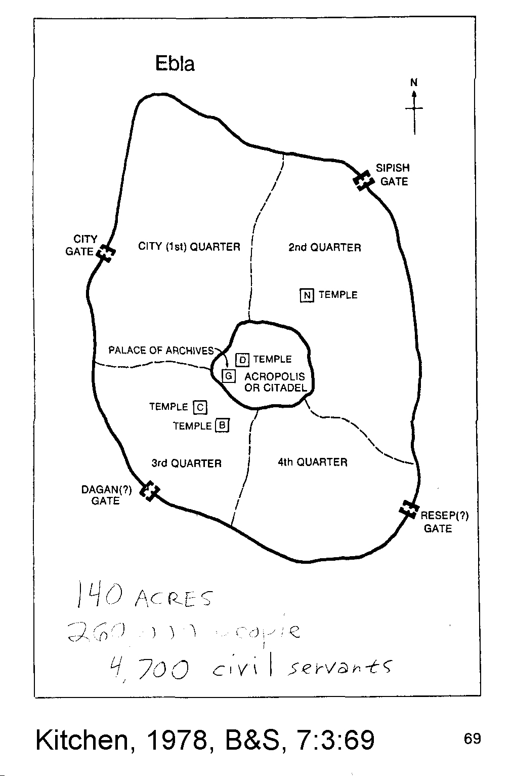

PHOTO LINK: EBLA 003 Photos Royal Palace G
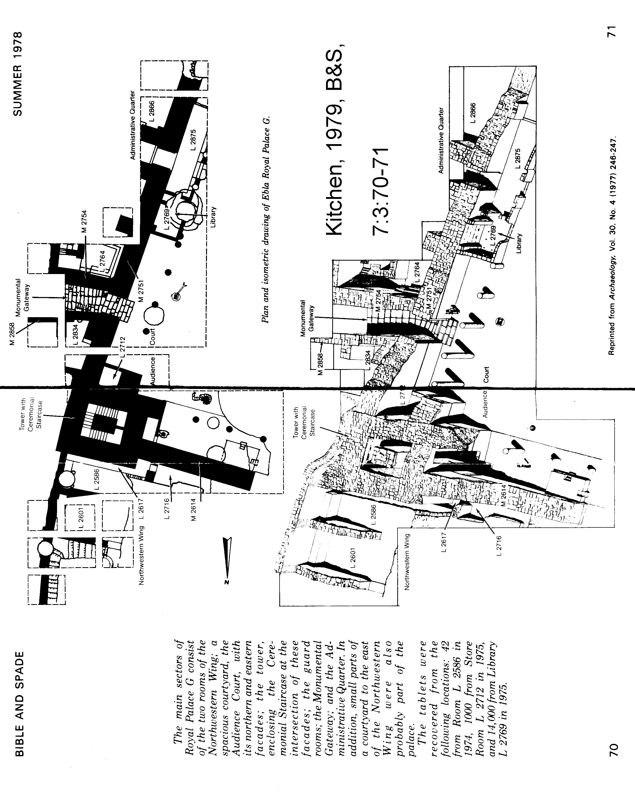

PHOTO LINK: EBLA 004 Royal podium at Palace G
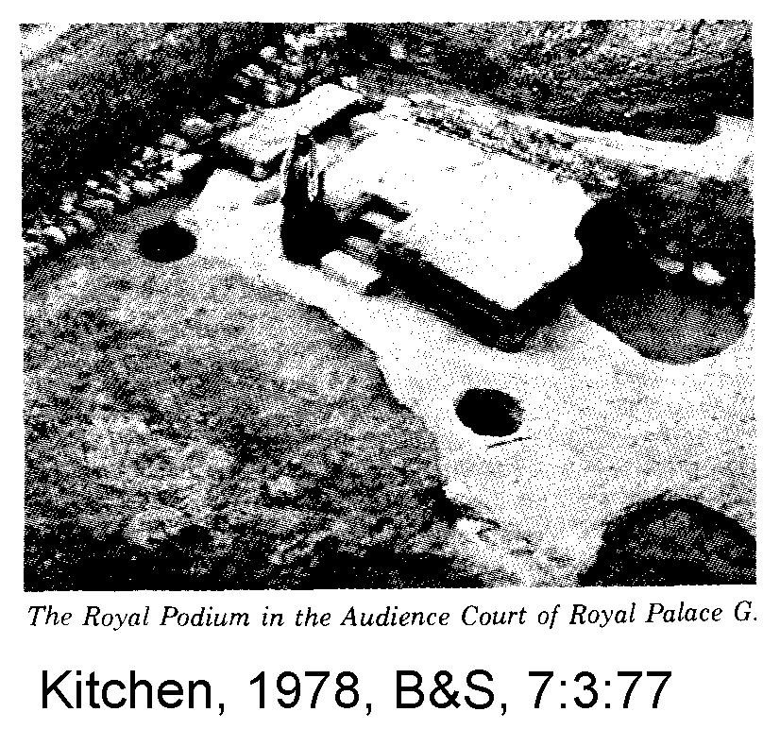

PHOTO LINK: EBLA 009 Excavations
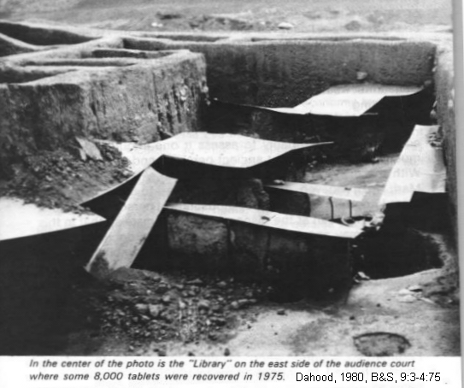

PHOTO LINK: EBLA 018 Diagram of Archives at Ebla
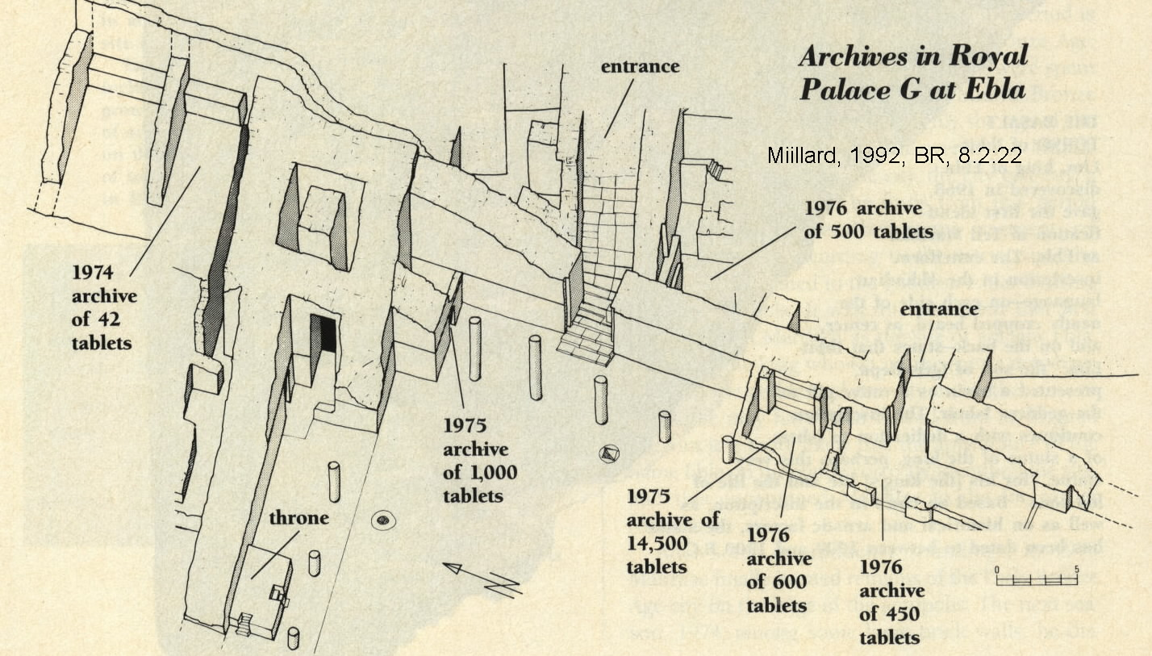

PHOTO LINK: EBLA 008 Stairway to interior
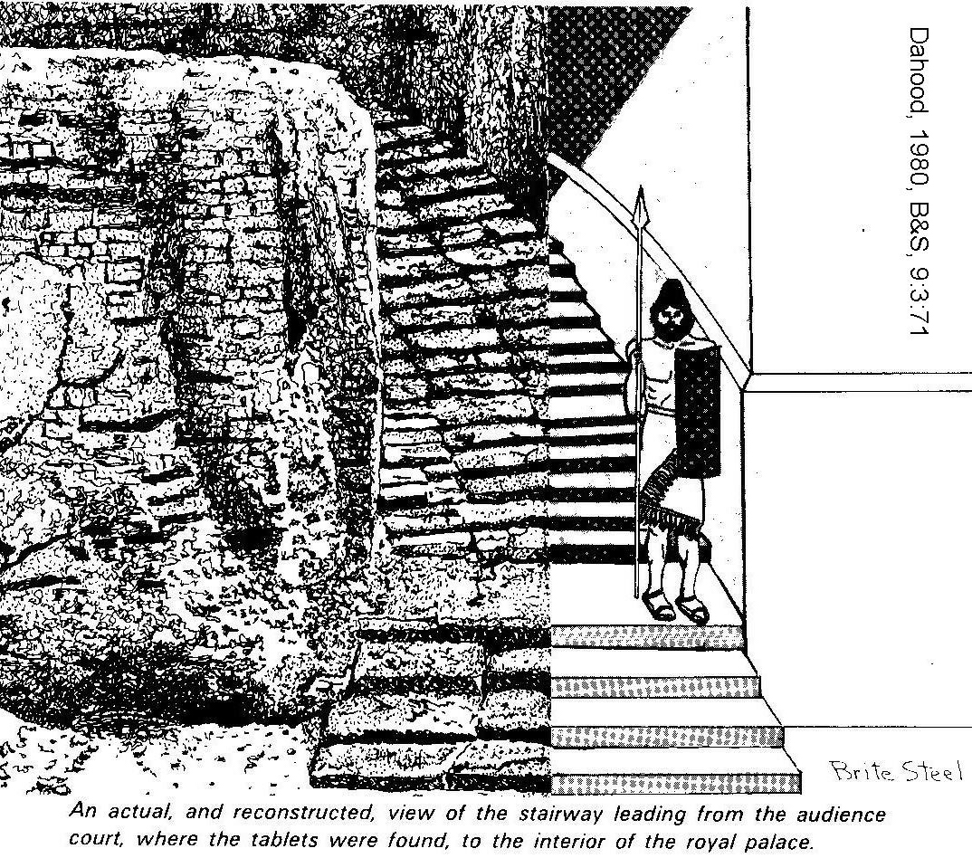
PHOTO LINK: EBLA 013 Palace G excavations, block diagram
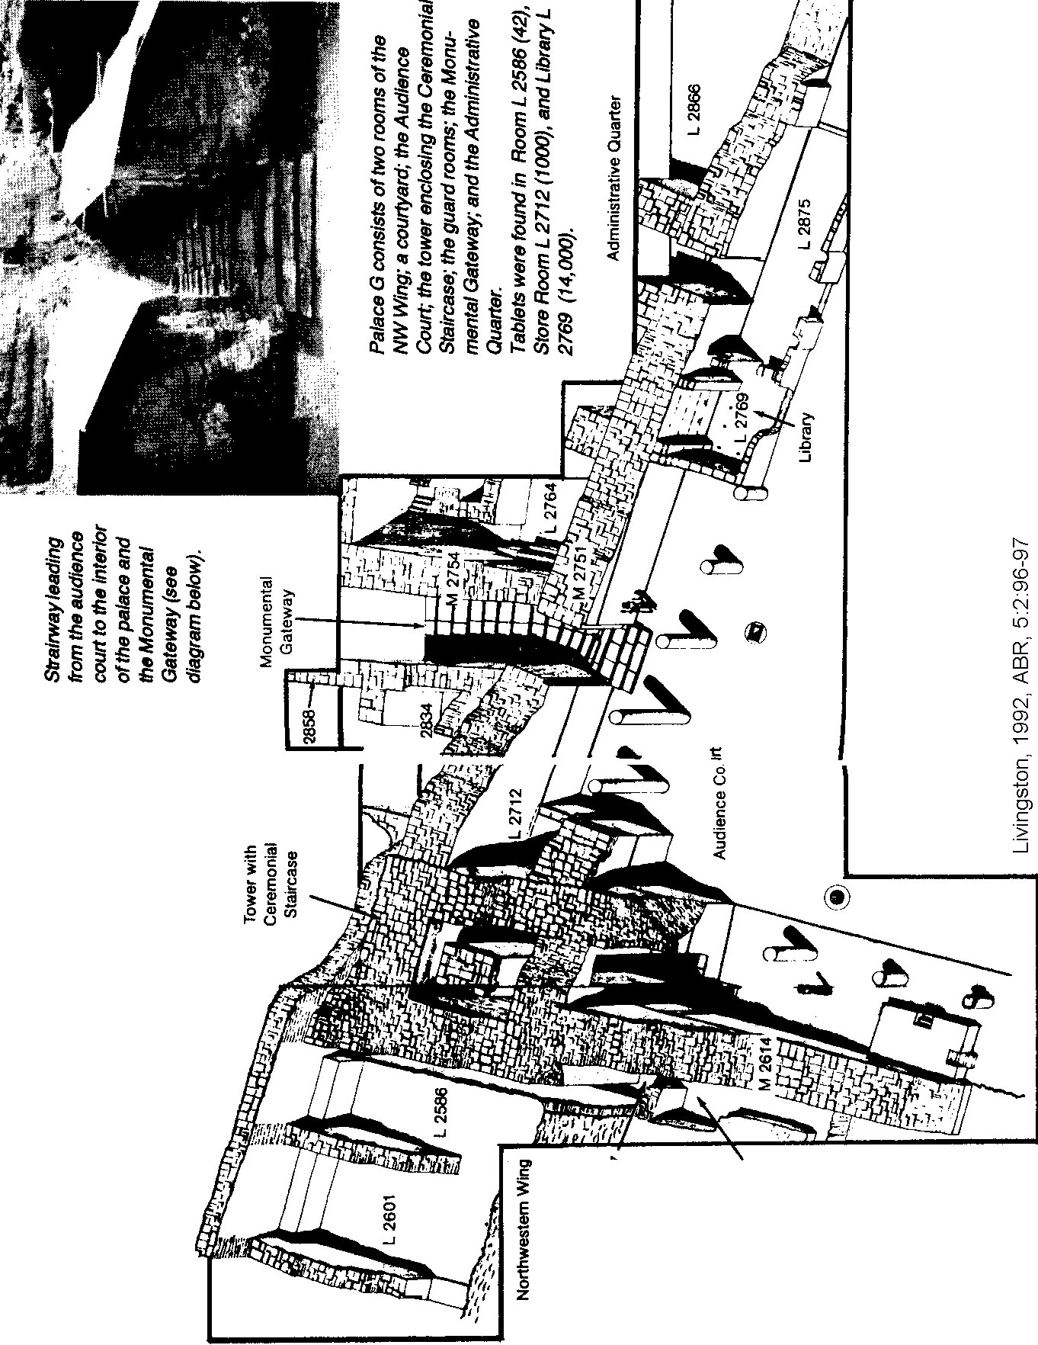

EBLAITE SOCIETY

At Ebla the “King” was elected to 7-year term. The Queen shared in state affairs. (Kitchen, 1998).

King Ebrium, who was elected 3 times, ruled 28 years, arranged to have his son Ibbi Sipish named as his successor, and thus created a dynasty. The tablets cover a period of only 60 - 70 years. Loss of democracy with the ascension of Ibbi Sipish may have lead to civil strife and Ebla's decline. The "Elders" were the wealthy merchants of Ebla. Artisans were probably organized into corporations. The government structure consisted of fourten provinces, each administered by governors. These provinces provided much tax revenue in gold. The Ebla calendar had 12 plus one (intercalary) month in order to synchronize the lunar and solar year. In the Old Elbaite Calendar, King Igrish-Khalam is the first king of Ebla. In the New Elbite Calendar, Ibbi-Sipish, is the last known king (Millard 1992; Livingston, 1992; Dahood, 1979, 1980; Pettinato, 1979; and Kitchen, 1978).

ECONOMY OF EBLA

The Ebla was an economic-commercial city-state, not a military empire. It had connections north to central Anatolia, west to Cyprus, south Sinai peninsula and east to northern Iran. 10,000 geographical names preserved in the Ebla tablets (Dahood, 1979, p.6). There were 11,400 "functionaries" attached to royal palace. Commerce included olives, vineyards, flax of linen, sheep, wool textile industry ,all of which were regulated(Millard 1992; Livingston, 1992; Dahood, 1979, 1980; Pettinato, 1979; and Kitchen, 1978).

The Ebla textile industry was central to its success. The main Ebla city is named A-RI-GA-AT, based on verb ARAG, meaning "to spin or weave", or a feminine plural meaning "Spinning Women". Linguistically, this word may be basis of Greek "arachne", spider's web. The word appears in Greek mythology's Arachne, a Lydian maiden who challenged the goddess Athena to a contest in weaving. The Eblalite city name BAD is like Hebrew word BAD for "linen." The Eblalite city name SHESH is like Hebrew word SHESH for "brightest, whitest linen." The Ebla place name SA-PI-TU is like a rare Old Testament word (hapax legomenon, Isaiah 21:5) SAPIT meaning "rug, carpet" and suggests a carpet-making industry (Millard 1992; Livingston, 1992; Dahood, 1979, 1980; Pettinato, 1979; and Kitchen, 1978).

Elba city or place name | Textile meaning
A-RI-GA-AT | to spin or weave
ARAG | arachne, spider's web
BAD | Hebrew BAD = “linen”
SHESH | Hebrew SHESH = ”whitest linen”
SA-PI-TU | Hebrew SAPIT = “rug, carpet”

LANGUAGE OF EBLA COMPARED TO HEBREW

The Ebla language was similar to Canaanite (Hebrew cousin-language "Old North Semitic"). For example, in Ebla's Old Calendar "November" is called gasum, meaning "rain". This is like the Hebrew and Ugaritic words for “November” which also mean rain. It is unlike the Mesopotamian or South Arabic words for “November” (Millard 1992; Livingston, 1992; Dahood, 1979, 1980; Pettinato, 1979; and Kitchen, 1978).

Forty percent of the Old Testament is in poetry, and much of that is "archaic." Of the 8,000 words in the Old Testament, 1,700 are ONLY found once in the received Old Testament text (hapax legomena). So comparison of these rare words to other contemporary languages is an important source of information about their meanings. There were 50,000 tablets at Ebla. Of these, there were 114 tablets with important bilingual vocabularies of Sumerian and Eblaite (3,000 words in translated Ebla tablets). These bilingual vocabularies can give important insights into proper translations of many verses in the Bible (Millard 1992; Livingston, 1992; Dahood, 1979, 1980; Pettinato, 1979; and Kitchen, 1978).

An example is one of Joseph’s titles, ‘ABREK found in Genesis 41:43 as a hapax legomenon. There is common interchange of B and G in Eblaite. The Eblaite words 'AGARAKUM or ‘ABARAKUM mean "superintendent". In the Joseph story it is recorded that: "He had him ride in a chariot as his second in command, and men shouted before him “ 'ABREK “, or “Superintendent” (Millard 1992; Livingston, 1992; Dahood, 1979, 1980; Pettinato, 1979; and Kitchen, 1978).

RELIGION AT EBLA

There are 150 tablets of religious literature. Three tablets contain Sumerian myths, two involving Uruk (know previously from other sources; Livingston, 1992; Millard, 1992). As with many cultures of the time, Ebla had 500 gods with 25 major deities. There were many weather and fertility gods, like those revered by Canaanites. Religion, in part, was affected by geography: agriculture in the Ebla region was dependent on rain, not irrigation. Ebla’s patron god was DA-BI-IR, in Hebrew DEBER , meaning "pestilence." Why would a prosperous city-state like Ebla want to have a God of Pestilence as chief deity? Perhaps because the Pestilence God kept plague AWAY from the city! The other popular god at Ebla was: NI-DA-KUL, or I-DA-QUL (NI can = I). This spelling is similar to Genesis 2:14 were the word HIDDEQEL, meaning "Tigris river", appears. These word comparisons are examples of linguistic evolution (Dahood,1980; Millard 1994).. A modern analogy would be our contemporary: Peking vs Bejing (China) and Khadafey vs Gadhafey (Colonel Gadhafy).

Ebla had a form of henotheism, the worship of one god above the others. This is deduced from the phrase "Lord of heaven and earth" which is mentioned in a hymn. The four city gates were named for the gods Dagan (head of Syrian pantheon), Resheph (Rasap), Baal and the sun-goddess Shapash (Sipish).

PHOTO LINK: DAGON 001 ; Line drawing; http://www.pantheon.org/areas/gallery/mythology/ middle_east/mesopotamian/dagon.html; July 26, 2005
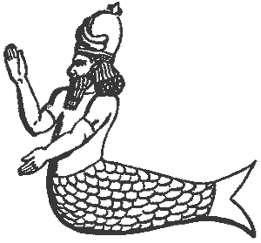

PHOTO LINK: DAGON 002 Drawing of relief of Dagon; http://www.crystalinks.com/ cybeledagon.html ; July 26, 2005
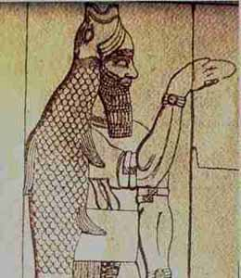

PHOTO LINK: BAAL 002
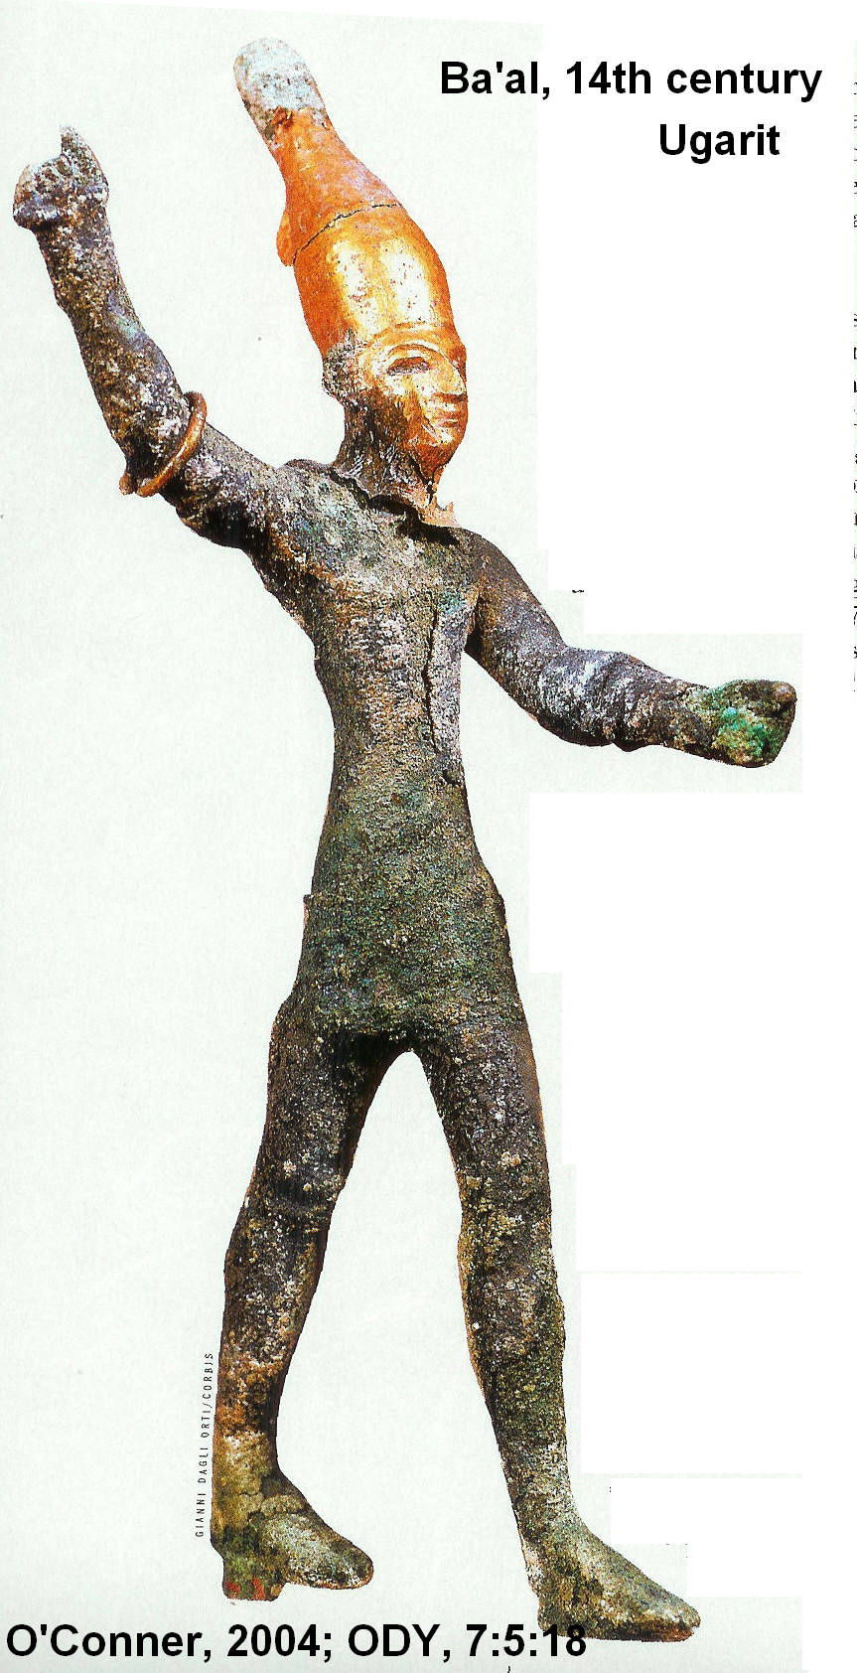

The Ebla religion required monthly sacrifices by the royal family. There were several classes of priests and two classes of prophets: makhkhu (ecstatic, dancing, singing) and nabi'utu (classic Old Testament-like, compare that Ebla word to the Hebrew’s word for “prophet”, nabi').

An interesting religious concept of Eblaite religion was "The Word", a concept also found in the New Testament (John 1:1 "The Word became flesh, and dwelt among us") and Old Testaments (Jeremiah 2:1). The Ebla word E-DA-DU means "Temple of Eros" while a similar Ebla word, E-DA-BAR, is a word meaning "Temple of the Word". E-DA-BAR is like Hebrew DABAR, or "word", occurs 1440 times in the Old Testament as a theological theme (e.g. "word of the Lord"). The Ebla god DA-BAR was an old god, based on the concept of "The Word". (Dahood,1980; Millard 1994).

Other linguistic comparisons between Eblaite, Ugaritic, and Hebrew are found in Dahood (1980) and Millard (1994).

Table of Divine Names

Many of the associations shown in the table, below, have been overturned by other scholars (Millard, 1994). Some of these re-definitions are indicated by ???.

Eblaitic or Ugaritic | Hebrew gods and god names | Translation
ABARAKUM | 'ABREK | ABAREK Superintendent
A-DA-MU | ADAM | Adam
ADMAH | ADMAH??? | Adam
A-GAR | A-GA-RU | HAGAR (Gen 16:11)
A-GI-A-LUM | HAGIYAH | Haggai "The Most High/Yah is my feast"
AN-NA-YA | x | Have pity oh Ya
'A-WA | HAWWAH | Eve
BA-RA-GU | x | the Voice has Created
BDY | ABADIAH | Obadiah "Slave of God"
BI-RI-DI-YA | BA-RA-DU | Euphrates
BRKH | BARIACK | fleeing or evil
CHAMISH | CHEMOSH | Chemish Moab's patron god (Chemish in Jer 48:7)
DA-BI-IR | DEBER | Pestilence (god) [see Hab 3:5 where he gets demoted and becomes Yahweh's attendant]
DAGAN | DAGAN | (god of) grain
DA-SI-MA-AD | x | He goat of God
da-si-ma-ad | x | the he-goat of the Grand
DA-U-DUM | DAVID | David
DDA-SHI-IN | DESHENIM | (The) Fresh (One)
DI-A | DE-AH | Knowledge
^{dingir-}YA-RA-MU | YO-RA-MU | Joram/Yoram (^{dinger} is determinative or semantic marker which signifies that -ya is a god-name
DI-SA-TU | I-SA-TU | (god of) Fire
DMA-NI | MANI | (god of) Mercy
DMRB'L | x | Baal is sentinel
DMRHD | x | Hadd is sentinel
DMRY | x | Ya is sentinel
E-BA-RI-UM | x | the Temple of the Creator
EN-NA-IL | x | Have pity
EN-NA-MA-AD | x | Have mercy O Grand (see Ps 46:2 and 78:49)
(E)-DA-BAR | DA-BAR | (Temple of) The Word
(E)-MU-RI-IQ | YE-RE-Q | (Temple of) The One that makes green
GA-SA^{KI} | GAZA??? | Gaza
GI-BAR-(GU-BI) | GIBBOR | Hero (of Gubi)
GOMMORAH | GOMMORAH??? | major town on Euphrates River not Dead Sea
GUBAR | x | standard jar for shipment of grain or wine. See Hab 2:5
GU-RA-RI-UM | x | the Voice is the Creator
I-A-A-KHU | I-A-RA-BU | Ya is brother
IB-RA-MU | ABRAHAM | Abraham
IB-TA-TA-GU | x | the Voice has Created for himself
ILTM | x | God is perfect
ILY | ELYAIA | Elijah
ISH-MA-EL | ISHMAEL??? | God has heard
ISH-MA-IL | ISH-MA-EL | Ishmael
KHA-HA-AN | HARAN | A city 220 km northeast of Ebla
LA-AT | LA-HAT | (god of) Flame
LA-DI-A-AT | EL-DE-OT-YHWY | The God of Knowledge
MA-DA | ME'OD | The Grand (formerly translated "much")
MI-KA-IL | MICHAEL??? | Who is like God?
MI-KA-IL | x | Michael
MI-KA-YA | x | Who is like Ya?
MU-SHI-LU | MOSHE-EL | Moses
NAM-RAD | NIM-ROD | Nimrod (Gen 10:8-9 Michah 5:5 and I Chron. 1:10)
NI-DA-KUL | HIDDEQUEL | Tigris River
NI-MI-RA-AD | x | Panther of Hadd (Baal)
NI-MI-RI-YA | x | Panther of God
QU-TU-RA | QUETURAH | Keturah (Abraham's 2nd wife ; Gen. 25:1-6)
RA-AN | RA'ANANNIM | (The) Green (One)
SA-U-LUM | SHA'UL | Saul
SI-DA-MU^{KI} | SODOM??? | somewhere in NW Syria not Dead Sea
TA-MI-MU | TE-MI-M | The Perfect one is Yahweh
TE-RI-ISH-TU | TI-RO-SH | (goddess of) new wine
THLKN | SHLKN | table
TMY | x | Perfect is Ya
TSITS | TSITS | salt mines (Jer 48:9)
WA-NA | YO-NA | Jonah (wa by phonetic rules becomes yo)
WA-NABI'-UTU | NABI prophet
YA-RA-MU | JORAM | Yo is exhalted
YA-RA-MU | YO-RA-MU | Joram/Yoram
YRMB'L | x | Baal is exhalted
YRM'L | x | The Most High is exhalted
YRMY | x | Jeremiah
YRM'Y | JEREMIAH | Ya is exhalted
YTM | x | Ya is perfect
YW'IL | JO-EL??? | Lord God
ZEBOIM | ZEBOIM??? | Zeboim
ZOAR | ZOAR??? | Zoar

Eblaite Religion and the God of Israel (Ya, Yahweh)

Mesopotamian names ENDING in -YA may indicate a diminutive and need not be a divine element at all. But! if YA- is at the BEGINNING of a name, then it is divine. An example is the Eblaite word YA-RA-MU, meaning "Ya is exalted". This phrase is similar to the content of 2 Samuel 8:10, 1 Chronicles. 26:25 and phrases for Ya found in 1&2 Kings (Dahood, 1980).

Other examples are: JORAM, "Jo/Yo (The Lord) is exalted" (Note: Eblaite long "a" becomes "o" in Hebrew) and YA-RA-MU = YO-RA-M (Yoram) Joram = "My god is exalted (if jo = ni as a first person pronoun). Note: a discussion of Joram is not included in the 1991 version of Pettinato's book (Dahood, 1980).

Eblaite I-A-A-KHU is similar to Hebrew I-A-RA-BU, both meaning "Ya is brother"

Other Hebrew/Eblaite diety words are:

I-A-GU-LU "Ya is Healer", or "Ya is Great" (or my god is healer/is great)
I-A-BE "Ya is joy" (or my god is joy)
I-A-GU "Ya is Master" (or my god is master)
I-A-MI-GU "Ya is the Voice" (or my god is voice)

Where ia or ya is transliterated as i, li or ni it may represent the first personal pronoun (singular or plural) or the value of a diminutive (i.e. Michael becomes Michie; John becomes Johnie) such as "Little Michael" or "Little John" (Dahood, 1980).

The divine names Yahweh, Ya or Yaw (Hebrew word translated "Lord") and El (Hebrew word translated "God") are found as constituents of some personal names like Mika-el or Mika-ya (English Michael). In Ebla tablets there is an NI replacing the el or ya, hence MikaNI. But other utilizations of NI, like in il-NI-ra-mu show that the NI is the possessive suffix so that word meant "my god is exalted". In this interpretation, NI is a sign that does NOT mean ya as a divine name (Millard, 1992).

Pettinato (1991) suggests that names ending in -el (e.g. Ishmael, Israel, Michael) were changed to -ya after the reign of Ebrium (e.g. Ishmaya, Israya, Michaya; Dahood, 1980).

Eblaite Gods in relation to Israelite Theology and Poetry

It is suggested by Dahood (1980) that the Hebrews borrowed many god-names from the Eblaites. An example is the motif of knowledge. The Eblaite name LA-DI-A-AT means "Belonging to Knowledge" and indicates existence of a Canaanite goddess of knowledge named DI-A-AT. The Hebrew equivalent is DE-OT. Exampes are (Dahood, 1980):

a. 1 Sam 2:3, El-DE-OT-YHWH, "the God of Knowledge is Yahweh"
b. Job 36:4 , TEMIM DE'OT 'IMMAK, "the Perfect of knowledge is with you. Scholars dispute the translation, does it describe God or a man?
c. Canaanite city, LA-DI-A, "Belonging to Knowledge"
d. Canaanite DI-A = Hebrew DE’AH, both words meaning “knowledge
e. Psalm 73:11says: "And they say, 'How does God know ' and "Is there knowledge (DE'-AH) in the Most High?”

Another god theme at Ebla that Dahood (1980) compares to Hebrew is the idea of God’s perfection. Ebla had a god with the personal name TA-MI-MU, "the Perfect One". This word is similar to a Hebrew word, TE-MI-M is found in the book of Job. The idea of God’s perfection in knowledge is found in Job 36:4 and 37:16. These similarities suggest a common cultural linkage of Elba and the early Hebrews (Dahood, 1980).

The idea of God being identified by compassion is found in Deuteronomy 4:31, "For a compassionate God ('EL RAHUM) is Yahweh your God". A similar spelling is found in the Ebla personal name: SU-RA-UM, "Lamb of the Compassionate". In Arabic Moslem theology, ALLAH is called AR-RAHMAN, "The Compassionate". Note the same root to all these words, RAHUM; indicating a kinship of Hebrew, Canaanite, and Arabic (Dahood, 1980).

Fertility is a concept universally applied to gods and goddesses. The motif was adapted by the Psalmist. In Psalm 92:13 and 92:15 where we read that "The just will flourish like the palm tree and grow like the cedar of Lebanon...Still full of the same in old age, they will remain fresh and green" (Dahood, 1980).

The Hebrew word for "Fresh" is DESHENIM and the Hebrew word for "green"is RA'ANANNIM. There was an Eblaite fertility gods who’s name was: DDA-SHI-IN, "The Fresh One" and another god named RA-AN, "The Green One" (Dahood, 1980).

EBLA AND THE PATRIARCHS

Middle Bronze Age Ebla was standing in patriarchal period. Among its tablets are a list of kings and royal ancestors used in a commemorative cult of the dead. These are similar to lists found in Middle Bronze Age Babylonia and Late Bronze Age Ugarit. The king/ancestor lists at Ebla can be compare to the genealogies of Genesis 5 and 11. Middle Bronze Age tomb chambers were found below Elba's palace court. A "princess" had gold jewelry including a nose ring reminiscent of Rebekah's jewelry in Genesis 24. The temple layout at Ebla was similar to later King Solomon's Temple (Dahood, 1980).

Nimrod

As noted in the table, above the personal name Nimrod appears in the Ebla tablets, the “mighty hunter before the Lord”. Until the Ebla tablets, the Old Testament was only place we knew about Nimrod. Ebla mentions Nimrod twice, once as "NAM-RAD" and once as "NAM-RAD, king of Bargau". Biblical tradition holds that Nimrod was the founder of several Mesopotamian kingdoms.

Adam and Eve

Hebrew ADAM is interpreted as equivalent to the Ebla A-DA-MU. Hebrew HAWWAH ("Eve") is equated with Ebla 'A-WA. If this comparison is correct, the name "Eve" was only known from the Old Testament until the Ebla tablets were found (Dahood, 1980).

Keturah

Abraham's wife after Sarah (Gen. 25:1-6) Keturah, Hebrew QETURAH is equated to Ebla QU-TU-RA, "the perfumed one". Five lines later in this text, the Eblaite city of KHA-HA-AN is mentioned which has a Hebrew equivalent: Haran. This city is where Abram and his Father settled after they migrated from Ur. Haran was 220 km northeast of Ebla.(Dahood, 1980).

Because the names Abram, Hagar and Ishmael occur together in Ebla texts, as well as the names of many other Old Testament personages, it has been said that Ebla had a common cultural heritage with the early Israelites (Dahood, 1980). As stated above, other scholars discount these associations.

